Strathblane Primary School and Nursery Class



Strathblane Nursery Class

A place to grow

Standards and Quality Report 2014-15

The information in this standards and quality report was gathered from various sources of evidence including:

* Teacher’s and Early Childhood Educator’s plans
* Class observations by the school’s Senior Management Team and Peers (Teachers and Early Childhood Educators)
* House meetings - photos, performances, notes
* Pupils’ focus groups
* Staff consultation
* Parent and pupil feedback from school events
* Parent and pupil feedback in Learning Logs
* Pupil’s work and jotters
* Wall displays
* Assessment information
* Minutes of Eco Committee, Pupil council and Parent Council meetings
* Attendance at parents’ evening and feedback
* Parental feedback
* Positive letters/emails sent in by parents and comments in Nursery Class comments book
* Staged Intervention notes of meetings
* School and Nursery Policies and records of developments undertaken through staff development and collegiate working

Using the Quality Indicators in “How Good is Our School?” and “Child at the Centre” - Strengths and Developments were identified, evaluations were made and standards for improvement were set.

Introduction

Strathblane Primary School has seven classrooms to accommodate seven classes. Academic session August 2014-June 2015 the school had seven straight classes. The nursery class is in a single room setting and has capacity for twenty children am and twenty children pm. The school is set in a beautiful location with extensive views and well developed grounds surrounding it. The children benefit from extensive outdoor experiences and have access to the grounds in all weather conditions.

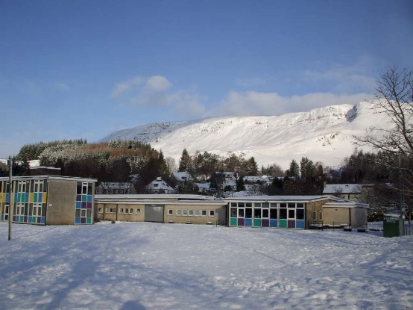

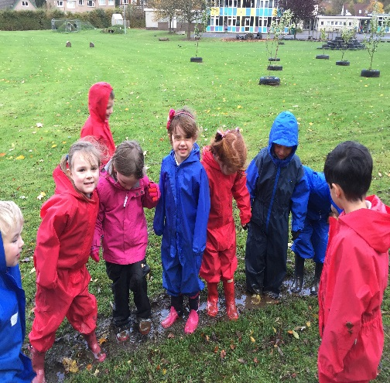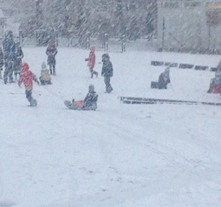

How well do young people learn and achieve?

School

Children in the school and nursery enjoy a broad and stimulating range of high quality learning experiences. Almost all children are polite and well behaved in school, and respond well to praise and rewards. They listen attentively to their teachers and other adults and visitors. Some children are working to better develop effective listening skills during group discussions or with each other. Children are motivated to learn and almost all remain on task during lessons, demonstrating their self-discipline and positive attitude to learning. Children are given the opportunities to take on different roles in school and are encouraged to develop their leadership skills through a variety of committees, responsibility roles and co-operative learning activities. Almost all children respond very well to working together in pairs and groups and as a result they are able to produce high quality work such as presentations at school assemblies, a Christmas Show in December, a pantomime in January in the local community, a Sports Week in the summer term, sharing the learning class assemblies throughout the year and a whole school Sharing the Learning Event for parents in June. These opportunities enable children to demonstrate their co-operative skills to their peers and the wider community.

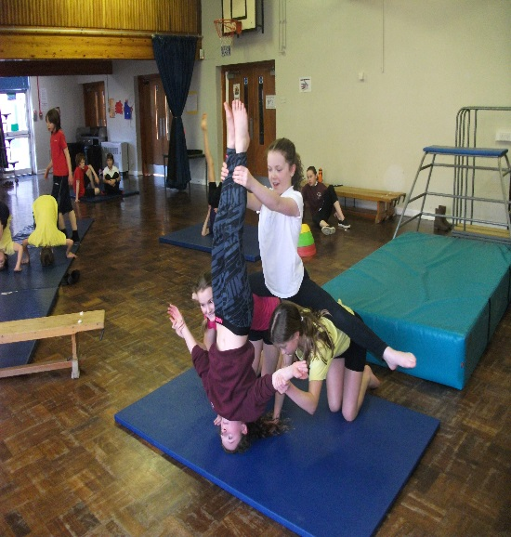

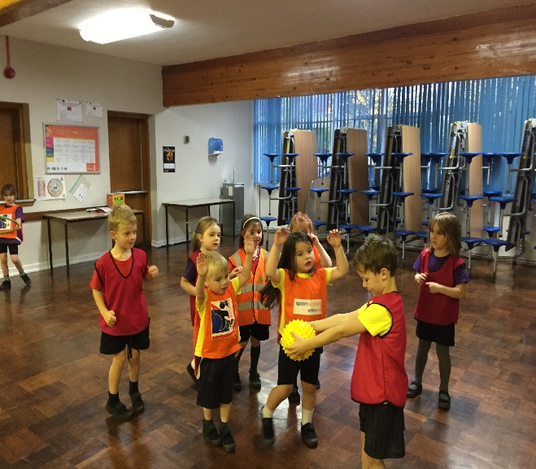

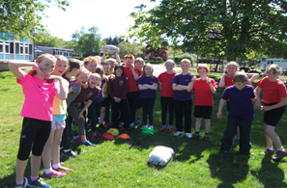

The children demonstrate citizenship and enterprise skills as well as responsibility throughout the school year in a variety of ways. The whole school and a member of the parent council was involved in developing the ‘Safe Routes to School Plan’ led by Miss Spencer DHT. Classes undertook enterprising fundraising events for charity and to finance class events such as the P6 fundraising activities to fund transport to Ardroy and P7 evening out to Laser Quest. Working on the school grounds, developing a raised bed area in the grounds and managing beds at the allotments also demonstrate these skills. Curriculum for excellence is embedded throughout the school and nursery and the philosophy of child centred learning is the focus of all curriculum planning in our school. In all classes teachers share the learning intention and success criteria with pupils to ensure they have good understanding of the purpose of the lesson and the expected outcomes. Children are increasingly more confident in helping to generate the success criteria for their learning. In all classes teachers ensure that pupils engage in their own learning by using self and peer-assessment alongside teacher assessment and this has increased children’s confidence and skills in evaluating their own work. Learning Logs help improve, over time, children’s ability to reflect upon and evaluate their own learning. These are shared with parents and carers and for some they make interesting reading.

One parent commented that “the learning log is good to read and it is very interesting to see how my son can describe his learning and evaluate how well he did because when I ask him anything about school he tells me nothing!”

All children are making very good progress in English language and Mathematics. Most achieve appropriate expected levels of attainment in reading, writing and mathematics. This year standards in maths continue to be monitored and the achievement of children has been raised through a focus on moderation of planning and assessment in mathematics by teachers working in small teams. Standardised assessments show that spelling, reading and numeracy has improved at all stages in the school and across all classes very good standards in reading is evident with many pupils working at levels above that expected for their age. The school has embedded consistent approaches for the teaching of writing resulting in children producing many different types of writing across learning including video presentations, posters, leaflets and personal projects. All pupils have undertaken a writing project again this year with many stating their enjoyment of this.

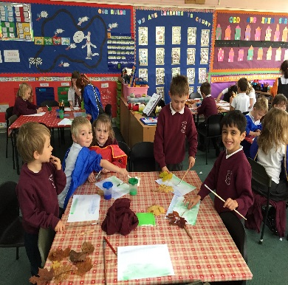One child commented that “I am really proud of myself because I wrote this story and made this lovely book by myself. Doing it made writing fun and my friends said it was the best book in the class.”

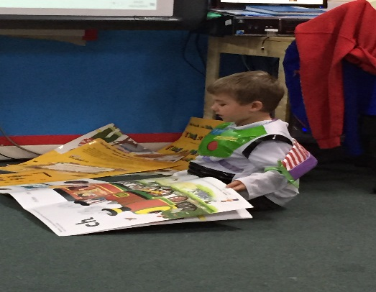

All pupils have been provided with opportunities to apply their learning and many have developed some of their mathematical skills within a real and relevant context. This has included: P7 Pantomime being run as an enterprise topic raising money for their end of year celebrations, p6 undertaking the 90k rice challenge to support sending a child in Malawi to school for a year by selling 90 bags of Fair Trade rice and P6 running a Healthy Tuck-shop weekly for all classes.

Children at all stages are continuing to develop their mental agility with numbers and are starting to show improving ability to demonstrate that they can apply their learning in various contexts.

This has resulted in them being successful with mathematics challenges including Sumdog, Manga High and the Junior Maths Challenge. Children in p7 took part in a range of local contests, winning on two occasions. They also participated in the Scottish Maths Challenge with three children achieving the highest score in Scotland. Further to this they took part in the UK Maths Challenge against S1 and S2 contestants and the children were awarded a range of certificates of merit from bronze to gold. Three children from p7 achieved the highest scores in Scotland and were invited to an award ceremony at St Andrews University where they were recognised for their outstanding achievement.

Children’s Health and Wellbeing is very important and extends to all aspects of interactions and relationships with others. Staff use restorative approaches to build positive relationships and behaviour and when dealing with conflict. Surveys of children’s views, including the Children’s health and well-being scale show that children generally felt that they are treated with equality, fairness and respect with staff working within the school values of respect, honesty, responsibility, fairness and co-operation. P6 children were trained in using restorative approaches and worked closely with children across p1-6 as mediators to support them during times of conflict. Pupil behaviour is generally very good, with a few children being supported to manage their behaviours with a range of classroom and outdoor strategies. Support staff introduced an award system to motivate children and reward good behaviour in the playground.

Staff aim to work in partnership with pupils and parents to resolve any problems with relationships as evidenced in the following quotes from parents:

“Thank you for your professional and compassionate approach to this issue. My child is feeling much happier as a result.”

“I really cannot thank you enough, first for listening and understanding but also for dealing so well with my concerns. My child had a great experience last week and I am delighted.”

Visitors to the school and parents who attend school events have commented on the high standards and expectations, good behaviour, and sportsmanship.

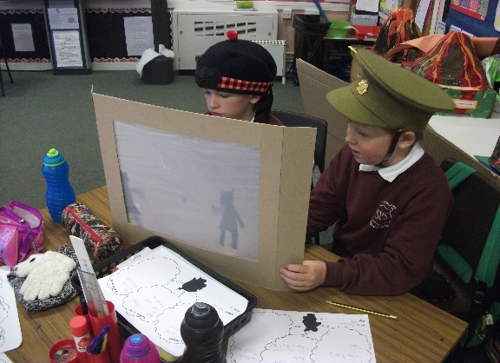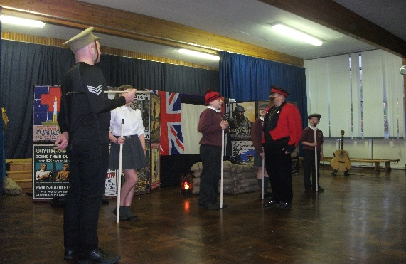

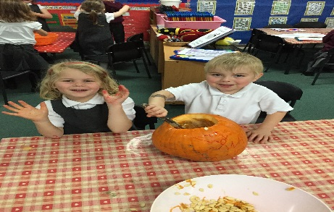Our school is fortunate to have a canteen and this year we welcomed a new catering supervisor, Mrs Hart to our school. All children p1-3 enjoy a range of delicious free meals and children who access the canteen for school dinners enjoy quality meals served by enthusiastic and friendly staff. Healthy eating is a focus of our school and children have many opportunities to sample home grown potatoes, tomatoes, cucumber and herbs. Several classes have made good use of the new cookers in school to cook. Curries, potato salad, and home baking have all been made this year.

The school is a vibrant learning community and the staff and children enjoy many successes. These have been reported in the local press and more recently the new school website, set up by Miss Allen. Some of these events include children who play for Strathendrick Rugby Club being recognised at an awards dinner for their ‘outstanding efforts’, and other teams and or individuals being commended for achievements in cross country, running, lacrosse, netball, football, drama, music, maths, chess etc.

Children’s work has also been displayed at local shows and several children who entered items at the Drymen Show received rosettes and commendations. Opportunities like these are highlighted to demonstrate how we as a community value the achievements of our children and also highlight the level of achievement across the school. Children are encouraged to try to be all they can be in their endeavours, to acknowledge the talents of others and recognise that their own may differ but we are all capable of achieving personal best. Parents and carers are encouraged to share their children’s wider achievements with staff either in a letter or via the learning log.

Parental comments show that parents feel that the school deals effectively with parental complaints or concerns. The school has had no formal stage 1 complaints this year

**Nursery**

In the nursery staff listen to children and respond to their interests. This has been demonstrated when peers and members of the Senior Management team have carried out observations, through parent responses and during planning meetings. Staff involve children in planning their own learning through group discussions and mind mapping. These plans are shared with parents and carers through the Parent Planning Folder. The children have particularly enjoyed the context of “Learning Through Stories”, and have been immersed in stories – acting out stories, creating new stories, telling stories through puppets, creating story settings by growing grass to name a few activities. Interviews were conducted and recorded by the children to find out their favourite stories. The children were learning the difference between a question and a statement.

Children generally behave well and are involved in setting the nursery rules which are reinforced by the happy flower system.

Staff work closely with parents to take account of any learning and development issues. Staff observe and record children’s learning and achievements in planning folders and in children’s Journals. They use this information to plan next steps in learning for each child. Activities are planned to meet the learning needs of each child. Where appropriate individual plans are created for children who require extra support with learning.

Outdoor learning experiences are embedded daily in the nursery routine and there are regular planned opportunities to use the school and nursery grounds as well as the local environment. Outdoor all in one waterproof suites allow the children to experience the outdoor in all weathers. This has meant that all areas of the curriculum have been implemented outdoors as well as indoors; including music, drama and P.E. Children in the Nursery Class are involved in planting and growing herbs and vegetables.

The nursery children also enjoyed a day trip to the Glasgow Science Centre. The children enjoyed the experience, especially the whole nursery going together.

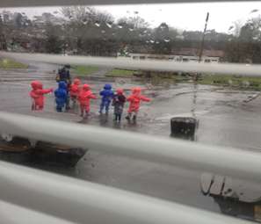One child commented, “The kite goes up ‘cos there is wind. It’s blowing up and then it goes back down and we need to catch it. The air wasn’t there anymore.”

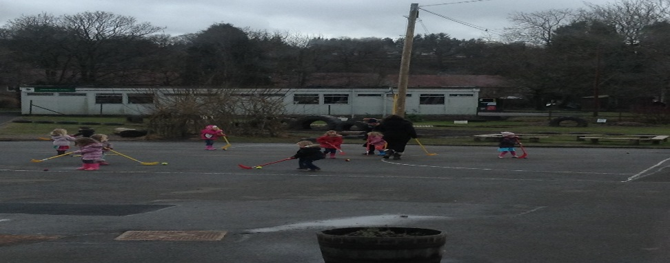

In the nursery classroom learning areas are regularly reviewed and staff interact very effectively with children to improve and take forward their learning. The physical class environment is continually improving and this has meant that both children and parents have commented on the welcoming environment created in the nursery. All parents have reported that their child feels safe at the nursery with many praising the good standards of behaviour and quality interactions between staff and children.

“I’m very impressed with the wonderful learning environment that is offered here. The children are so happy – all thanks to the tremendous staff”

“ A warm, nurturing environment in which every child is happy.”

“My child has grown and flourished in this fantastic nursery.”

“My child has thrived at the nursery and has really enjoyed his time here. Thank you so much for everything you have done for him …”

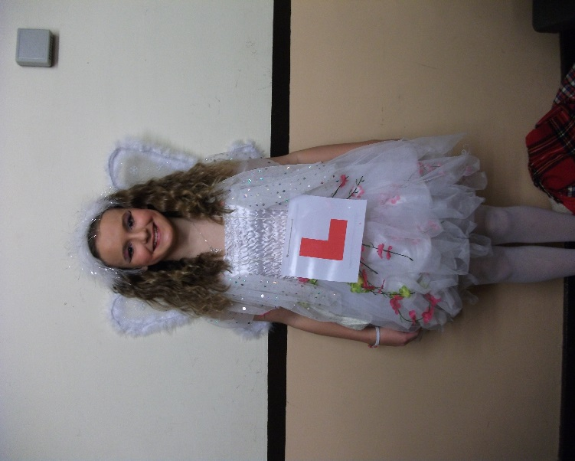

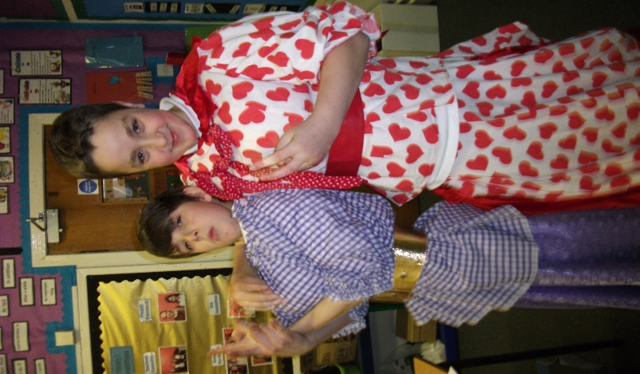

# How well do staff work with others to support children’s learning?

**School**

A range of assessment data, teacher professional judgements and quality assurance procedures are used to monitor and track children’s progress and ensure early intervention where support or challenge is required. Staff undertake shared planning sessions and moderation of the standards to ensure consistency of opportunity, regardless of the teacher’s individual teaching style or approach. Children with additional support needs are identified as a result of this approach and are then supported by staged intervention, a formal process of planning support, monitoring and reviewing outcomes and progress with parents. The school makes very good use of productive links with educational support agencies to support children with specific learning needs. Parents have praised the school for the additional support it provides for children identified with additional support needs. School continue to develop their skills and practice in inclusive approaches in line with GIRFEC (Getting It Right for Every Child) policy to support learners’ needs. As a result children are identified early and a child focussed plan is implemented to ensure they have support as required. Parents and children have commented positively on the school approach.

“I really feel the staff know my child well. They work really hard to ensure my child has the best support possible in class and beyond.” Parent.

“I think I am getting better at good choices when I feel angry because everybody is helping me understand how I feel and what I can do about it.” Child.

Children moving stages or school are supported by very effective transition plans.

Transition from nursery to P1 spans the year with regular shared planning events by teachers, regular visits to and from nursery and a planned programme of transition involving all early years staff and Miss Spencer in term four which involves parents and carers until their child is settled in p1. One parent commented that, “the transition organised by the school has been really very effective. Thank you for your hard work in doing this and preparing the very useful presentation we had this week. I know my child will be safe and happy in school.”

Transition from p7 to S1 also spans the year with regular visits from lead learners from Balfron High School, regular discussions between leaning community HT’s feeding into Balfron High and the High School staff. Children supported by staged intervention have a member of the High School support staff attend their P7 reviews to ensure a smooth transition and the High school runs several transition formats to support vulnerable pupils through ‘Art link’ or the enhanced transition six week programme. For all other children two days are organised to give the children and parents opportunities to visit the school and hear about the work and expectations of the school. Effective and well planned transition ensures children are well prepared and supported for the changes ahead and relieves an element of anxiety.

All pupils are provided with a broad and varied curriculum which has appropriate breadth at all stages. The school has made excellent progress in developing the curriculum to reflect the principles of *Curriculum for Excellence*. There is a strong emphasis on cross-curricular learning and multidisciplinary learning. Staff have this year worked together to review the science curriculum and have planned a progressive programme of work across p1-p7 which will now be implemented. There has been an emphasis on high challenge at all stages with children often working on tasks using a critical skills approach. When working on contexts for learning the children generate some “Big Questions” that will help to challenge their research and presentation skills. Children continue to benefit from visiting specialist teachers of music and physical education and peripatetic musicians teaching individual children chanter, violin, piano and ukulele. Children are given opportunities at assemblies and events to demonstrate their improving skills. The children also had the opportunity to join the school choir which was set up and run by a parent volunteer. Children have the opportunity to learn some Scots songs and poems and in term 3 and the Burns Club judged the best recitations from each class.

All pupils have at least two hours of planned good quality physical education each week and are given the opportunity to try other sports provided through the Active Schools programme after school clubs and a very successful School Sports week. Some comments include;

“It was just great fun really and I loved all the events” p3 child.

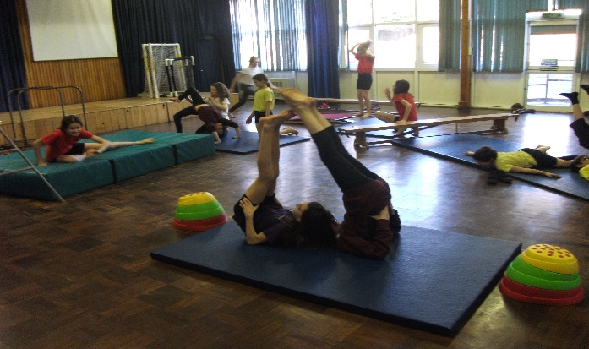“The children are being offered so many great opportunities. Thank you to all who organised this on their behalf” volunteer parent.

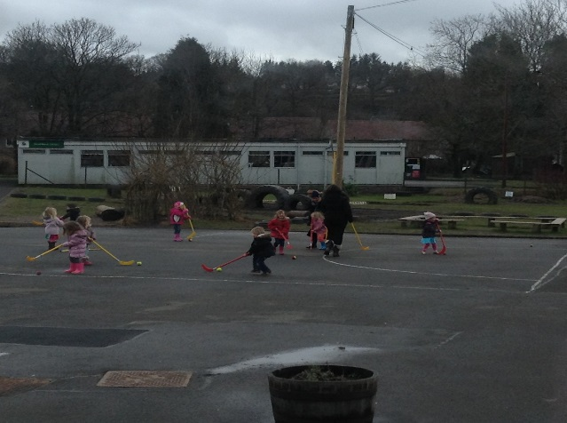

Children at all stages have benefitted from a range of trips and visitors to school. P6 undertook a week of residential activities at Ardroy alongside two other local schools. While enjoying this trip the schools participated in the John Muir Award. This work will continue with the children in early p7 culminating in a celebration to recognise their achievement around October. Other trips/events included Edinburgh Castle, The Glasgow Science Centre, Theatre, Mugdock , Librarian visits, author visits, food bus, park rangers, drama groups to name but a few. One child’s comment sums up the joy of a school trip.

“It was the best time of my life. I did so much and learned so much. I want to do it all again!”

Children are also supported through effective communication. Parents receive and share information through termly newsletters, class notes, sharing the learning events, planned parent consultations, comments in jotters and learning logs and the annual written report at the end of the school year. Parents are happy with the feedback they get about their child’s learning, commenting positively on the quality and content of the teachers report. Almost all parents have identified as a major strength of the school, parental and community involvement and communication. Communication has improved further by the introduction of group e-mails, texting service and more recently our new school website. This was set up by a member of staff as part of their collegiate responsibility/leadership role and was successfully launched in term four this year. Feedback has been very positive, with comments including, “the website is great. I love seeing photographs of what is going on and I can refer back to things when I need to.” A new plasma screen in the front entrance was purchased by the parent council to highlight the activities of the school to visitors. This year the school will be developing an ICT strategy, led by a member of staff. We will be seeking views on further use of technology in school and more opportunities for communication through technology.

**Nursery**

2014 saw the start of the increased hours for nursery children. The introduction of 600 hours saw an increase in staffing in our nursery class. This enabled staff greater flexibility and the opportunity to have quality non-contact time during which they could plan more effectively and evaluate the work of the children. Staff have also benefitted from opportunities to meet together and collaborate on planning and nursery improvement.

At the start of the year nursery staff and the Primary one teacher planned a series of events which enabled the children in nursery and primary one to work together to explore forces in the school**.**

The children are regular visitors to the local Library where they have opportunities to listen to and discuss stories. Staff make excellent use of the outdoors and as result children’s risk assessing, gross motor skills, confidence and resilience has improved. In addition to these improvements children are now more aware of sustainable living and healthy lifestyles.

Parents receive regular information through newsletters, the sharing the learning event, two planned parent interviews, information at the start of nursery sessions and an update at the end of sessions. All children get a written report at the end of the year. When children start in the Nursery class they are supported by their parents and nursery staff until they settle in. After 6 weeks staff meet with parents to update them on their child’s progress.

Nursery staff work closely with the dental hygienist who regularly visits the nursery to speak to the children on the importance of looking after their teeth. On her last visit of the session she commented that the children in Strathblane had the best teeth in the Forth Valley Area.

Parents are always welcomed into the nursery to share their knowledge and skills. The children benefited from sessions in the gym hall with a parent where they were working with paper and balloons. On another occasion a parent came in to share his musical talents with the children. The children listened to the violin and trumpet being played and some were fortunate enough to try playing the instruments themselves. The children continued their music making when they took part in a drumming workshop before Christmas. One child said “We were playing the drums. We had to put headphones on because it was a bit noisy!”

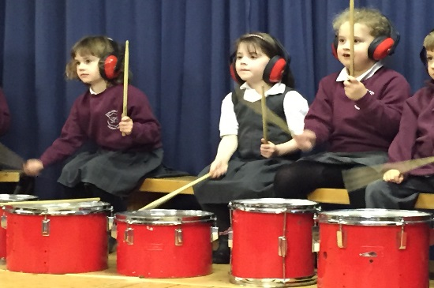

Rangers from Mugdock Country Park have worked with the nursery over the session helping children to plant trees to form a safe boundary fence around the playground. Rangers also set up a woodland adventure of the children enabling them to find out information about woodland creatures much to the delight of the children.

In November the nursery held a very successful open day for parents and carers to come and experience the nursery for themselves. During a ‘juice day’ the children made juice drinks for the parents and found out which juice was most popular.

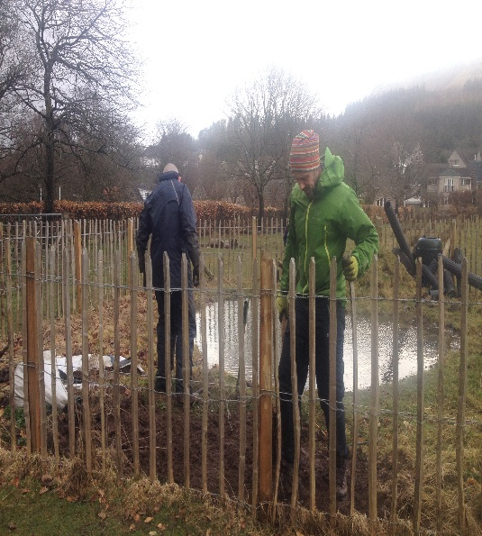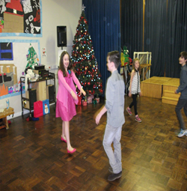

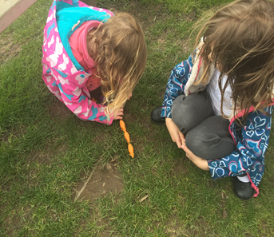

# How well do staff and children get actively involved in improving their school and nursery community?

**School**

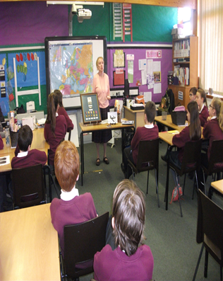The school plays a very active role in the local community and where possible parents, carers and members of the wider community are invited to attend school events such as the P7 pantomime, Burns recitals, sporting events, concerts, assemblies and sharing the learning. This gives the children the opportunity to demonstrate their learning and skills, while forging positive relationships. The school regularly welcomes parent and community volunteers to work alongside staff and janitor to enhance the children’s experience. This year events supported by this approach include, cross country, school choir, archery, netball, football, amongst many.

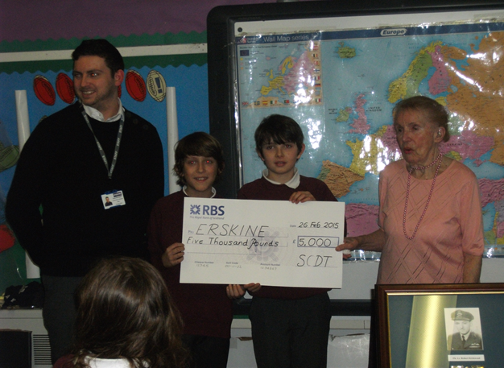

The children actively support a range of charities through fundraising events like Children in Need, Macmillan coffee morning, Erskine and recently gathered basic items to support a local family who lost their home to fire. The family commented that the children who delivered the speech and all the bags of donations were “so compassionate and polite. Although I was upset and couldn’t hide it the efforts of the school in supporting us with such kindness and generosity brightened what is at the moment a very dark time”. Opportunities to demonstrate the school values and citizenship skills in real life contexts are invaluable in teaching our children about helping those less fortunate.

In preparation for the village Remembrance Service the children in p7 worked with a local journalist, Anne Johnstone who was involved in writing the book “A Village Remembers”. Each child read a chapter and researched the life of the fallen hero and at the village war memorial they laid a cross in remembrance. The family members who were in attendance at this event commented on how reverent the children were and how moving it was.

Since January 2015 the school has been working towards achieving its first Green Flag and ECO status. An action plan of nursery and school involvement is in place and all stages contribute to it. In May the whole of the nursery and school, supported by staff and parent volunteers undertook a village litter pick. This wonderful community event was supported by Gregs, who provided cakes for the children.

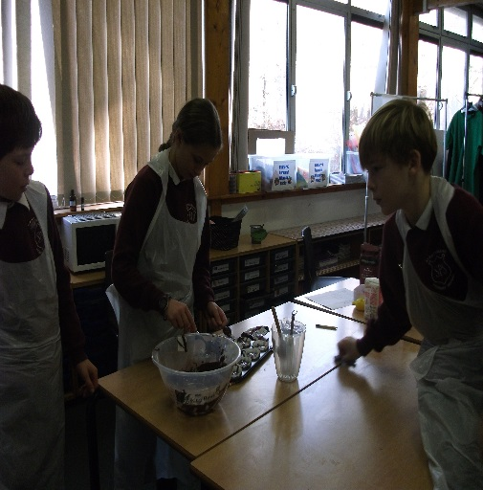

The local librarian has worked closely with staff to arrange reading events at the school and regular visits to the local library. This year P1 children benefitted from an author visit as part of their ‘We are going on a Bear Hunt’ project. Termly Chatter books Club continues to provide opportunities for children to meet, read and review books, sharing their views and opinions.

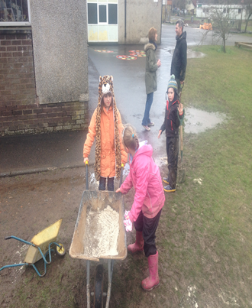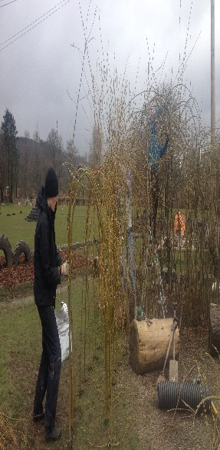

The Parent Council is very active in supporting the school with identified school improvements and the focus for those improvements this year has been to continue to develop the outdoor learning environment and provide funding to the school for enhanced ICT.” The grounds are a treasure trove of places to play and hide and the recent weekend Welly Day was a huge success despite the inclement weather.

Parents carers, children, local community and staff worked together to maintain the grounds and provide enhancements such as the extension to the willow den and the pond clearance. Hard work spurred on by homemade soup and cake resulted in it being a superb community day. Comments about the grounds from visitors in general include how “fantastic, well designed and fun” they are.

Parents have also organising events such as a Hallowe’en Disco, Christmas Fair and Summer Fair. They have raised significant sums of money and this has been allocated to the school for

* 100% transport costs to events where children are representing the school and 50% towards transport costs of school trips.
* A significant donation to enhance ICT
* Funding for materials to enhance the children’s learning experience including gardening tools, dress up clothes, an array of craft materials.
* Playground markings
* P7 leaver gifts
* A new plasma screen for the front entrance

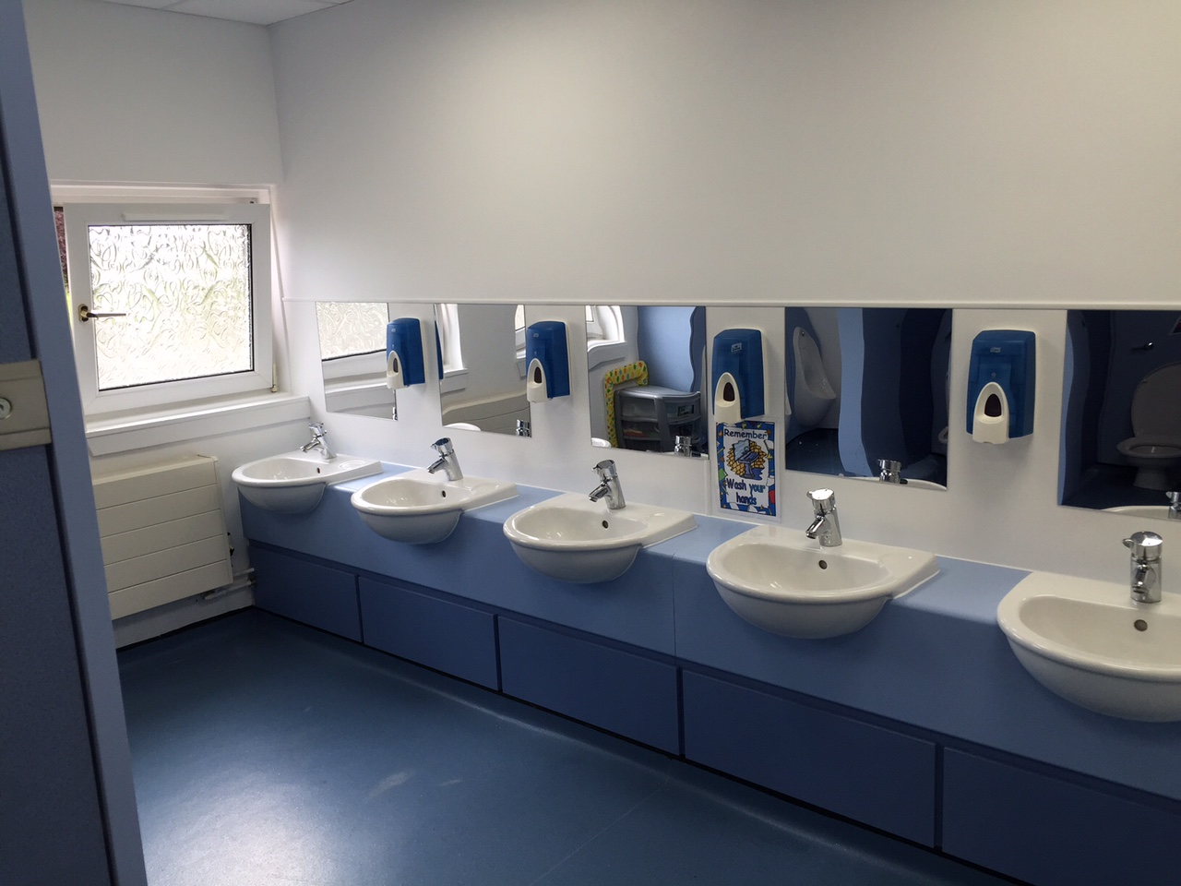Strathblane Primary has over a significant number of years declined into a poor state of repair. Since January of this year the new HT has pursued a programme of upgrades across the school and to the infrastructure of the school. Working in partnership with Stirling Council, the janitor and using creative budget management the school has been upgraded to include

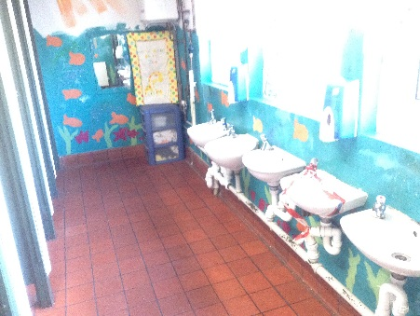

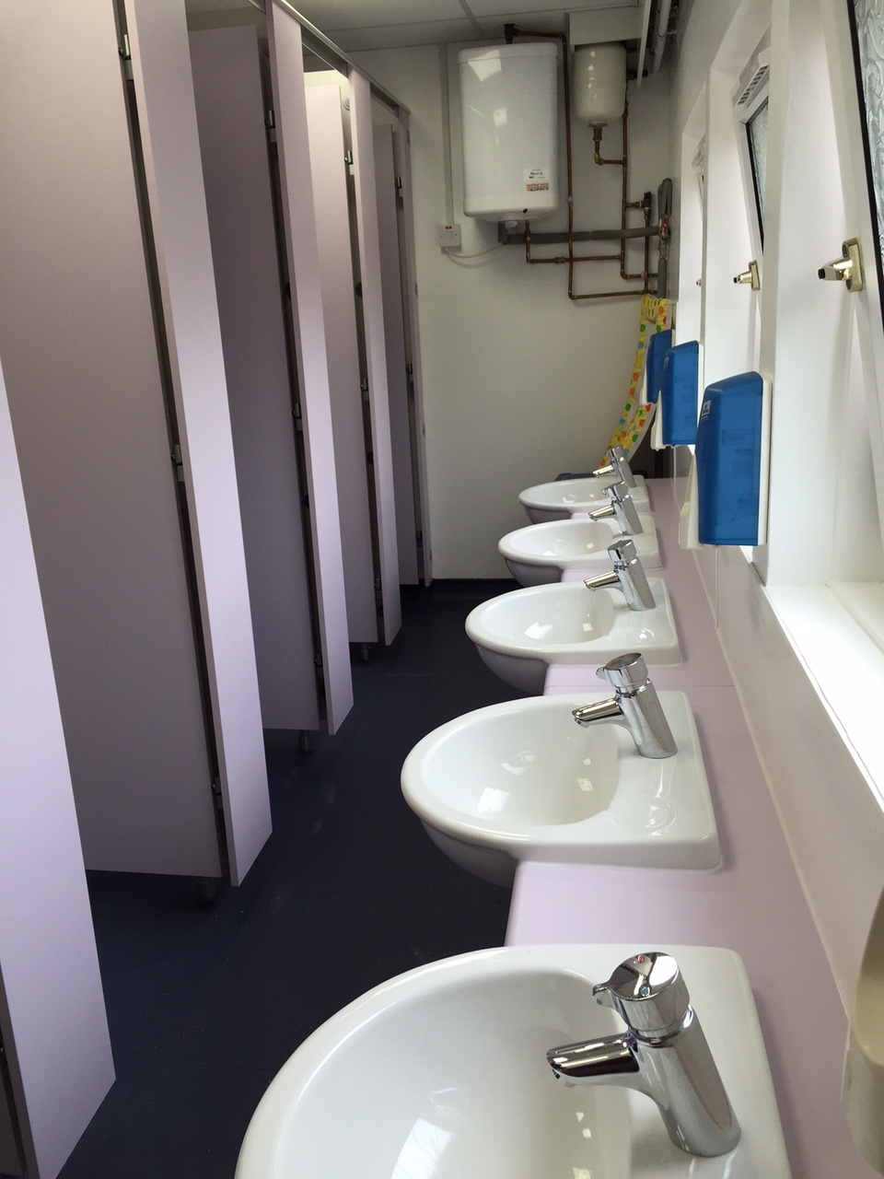

Infrastructure-

* Lowered ceilings and ECO lighting throughout providing brighter classrooms and work areas.
* New fire alarm system and magnetic door holds to allow free flow of traffic through the school
* Refurbished toilets in four out of six sets.
* A new boiler room is planned to house the boilers for a new heating system next year. This should help with the uncomfortable temperatures in winter and also provide hot water finally for the nursery.

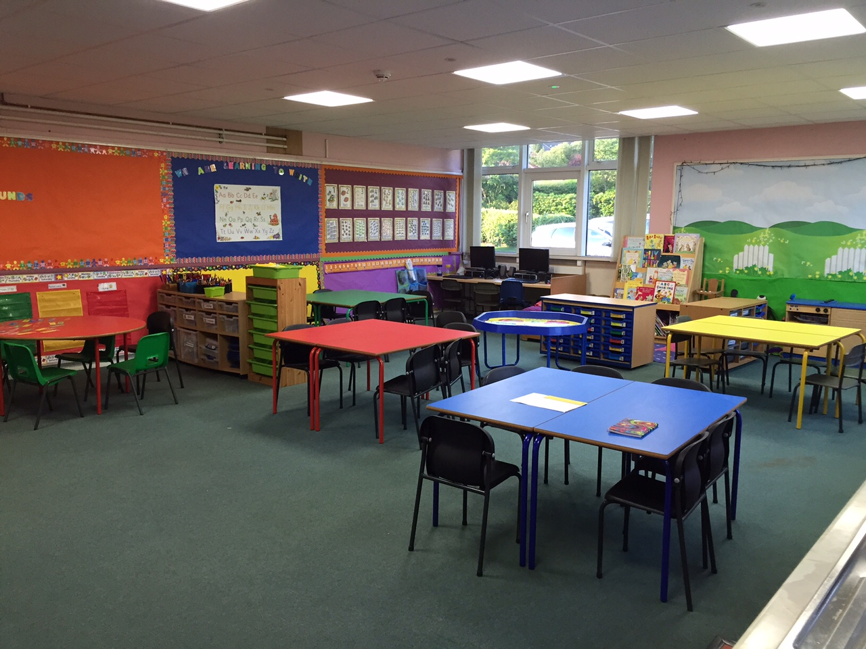

School

* Storage and resource management systems have been fully reorganised
* A range of new core resources have been provided for staff use
* Display materials and art/craft materials have been purchases
* New display boards have been purchased and installed by our janitor across the school
* A new dedicated staff working area was created and a computer station build by our janitor.
* New computers were purchased for the work area.
* New coloured furniture and resources for p1
* Additional new furniture and resources for nursery

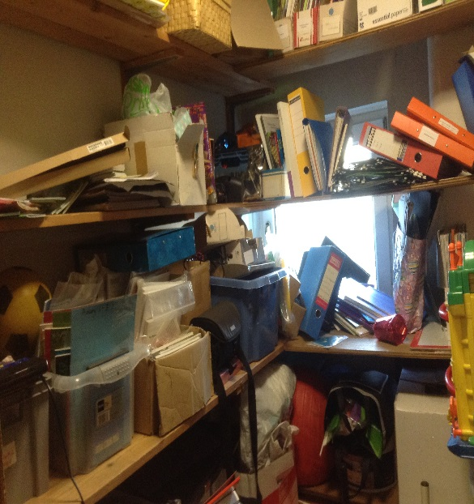 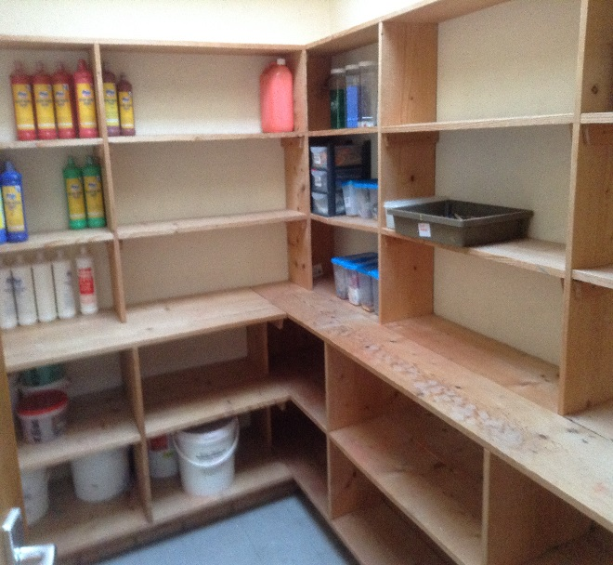

All of these improvements reflect the value we placed on our children and staff working environments.

Some of the comments about the improvements include, “wow, have you seen the new toilets? They are amazing” and “it is so bright around the school now” and, “I have the prettiest furniture in the world!” (Teacher!)

**Nursery**

Staff continue to develop their skills through professional dialogue, visits to other establishments and professional reading. Staff are open to new ideas and are willing share and develop good practice.

Children are encouraged to express their thoughts in the nursery. Staff listen closely to children recording their conversations and respond to their ideas and suggestions. This has improved the learning experiences and quality interactions between staff and children resulting in improved progress with learning.

Staff regularly use technology and photographic images to record and evaluate children’s learning displaying these images on the walls, in the planning folders or in children’s journals.

Positive behaviour continues to be promoted in the nursery and this year this was led by a learning group who focused on the happy flower in the nursery. The group interviewed the children to find out what they thought made a happy nursery. All the children had the opportunity to design a happy flower and a vote was held. Each child had a sticker to put on the design they wanted to have in the nursery. The learning group counted the scores and announce the winning design. During circle times the group talked about ‘rules’ they wanted to have for the nursery. To date this has had a positive impact on the children being able to regulate their own behaviour and the behaviour of others.

After a series of planning meetings between nursery staff, the senior managers and also a consultation with the children, the decision was taken to change the layout of the nursery. The children gave their views –

“I want to swap snack and construction.”

“Put the puppet theatre in the story corner”

“Change the art table”

“Put the bin beside the art table and we can chuck in rubbish”

“I want the construction area into the home corner so you don’t get squashed by the big table”

“Put the circle table beside the window”

The children also looked at catalogues to see what would improve the nursery, selecting a range of colourful storage options, a new sofa and some bright rugs.

The new layout received a positive response from parents, children and staff.

# Does the school and nursery have high expectations of all young people?

All staff are keen to continuously improve their own practice and the quality of experiences for children. They operate very effectively as a team to take forward priorities in the school improvement plan. This year staff have been working in moderation groups to plan and assess children’s work in a range of curriculum areas including maths and literacy. All teaching staff set success criteria for learning activities. Exceptionally good work is rewarded with a Wonderful Work Award and children’s achievements are celebrated publically and by displaying their Amazing Achievers Awards for all to view. Teachers and children take pride in presenting their learning in a range of displays throughout the year and this reflects the value placed on displaying children’s work and in sharing the learning. Children are clear about the expectations of staff in terms of behaviour, attitude and application to their work. Children are encouraged to try their best at all times. We have a set of school values which staff and children are asked to demonstrate in all they do. We recently adopted the motto, ‘Be all you can be.’ Children and staff are proud of their school and achievements.

Teachers and Early Childhood Educators (ECE’s) evaluate their own practice regularly to ensure they are providing the best possible teaching and learning for the children. Staff professional review is used effectively to identify staff strengths and aspects for further improvement. All staff have undertaken a range of relevant staff development activities and have shared the benefits with others. Some of this year’s activities include visits to other schools and nursery classes, team teaching in school, mentoring of probationer teachers, critical skills training, maths moderations of literacy and maths, child protections training, management and leadership courses and membership of various working parties across the school and cluster to name but a very few. These provide staff with opportunities to further develop their skills and improve their approaches in school. Mrs McCormick was trained to teach Gaelic and this was introduced to p5.

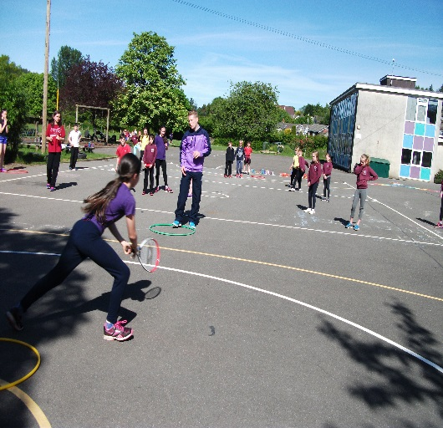 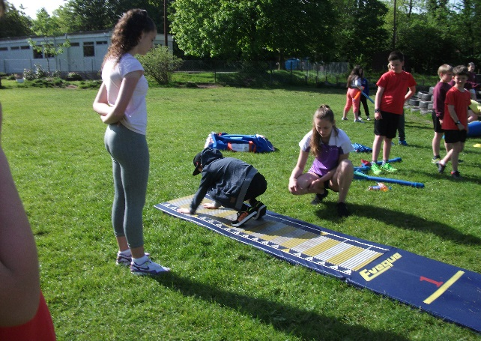

The Head teacher and Depute Head teacher undertake rigorous quality assurance. They monitor planning, progress and classroom practice regularly and provide staff with verbal and written feedback to improve learning, teaching and attainment.

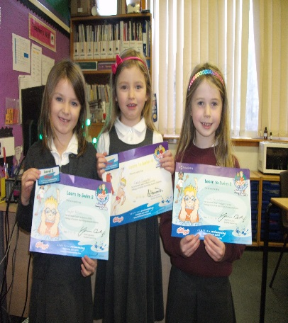All teachers, ECEs and support staff promote the school’s values and have high expectations of children’s learning, achievements and behaviour. The school celebrates achievements in assemblies, wall displays, the school website and the local newspapers. Children are proud of their school and nursery, most have high expectations of themselves, and almost are willingly taking on responsibilities and challenges.

Teachers, SLAs and ECEs encourage all children to review and evaluate their work to improve until they feel that this is the best they can produce. Staff and pupils use a house system to encourage children to achieve well. The constant use of success criteria means that children have standards to meet and measure themselves against.

All staff are trained in child protection and are clear about their responsibilities. The school takes appropriate and immediate action if children are absent from school without explanation. Staff use appropriate policies for ensuring children’s care and welfare, including safe internet use and anti-bullying. Staff place strong emphasis on helping children to develop their understanding of healthy lifestyles and this includes a school approach to relationships, sexual health and parenthood, and building children’s resilience. Children are trained and encouraged to take the lead on restorative approaches and this included Peer Mediators at p6 and Playground Buddies at p3. Almost all children report finding this useful and helpful in resolving conflict. A few children have been identified as needing some additional support in this area and action plans have made to support these individuals. Support staff in our school work exceptionally well with children to support their learning in class and also their behaviour in the playground and lunch hall. They also support staff with a range of activities including display, small group working and individual support.

The minister from the local church visits the school monthly to provide opportunities for religious observance and other community members provide the opportunity, for those children who want to, to attend Scripture Union Club and camp. He also contributes to the school by running an after school archery club with other parent volunteers and staff.

The process for school improvement in embedded in the school and there is a culture of continuous improvement. For this to be truly successful and have a positive and lasting outcome for our children this requires a high level of partnership from all in our learning community. It is our collective responsibility as parents/ carers, community and staff to provide our children with the best possible learning experience and to equip them academically and socially for their future lives and work. A favourite old African saying ‘it takes a whole village to raise a child’ sums this up. With this in mind staff will continue to foster strengthening partnerships and engage all those responsible for any aspect of our children’s lives in the process of evaluation and ongoing improvement and we look forward to continued support from families, community and external agencies in ensuring we ‘get it right for every child’ (GIRFEC.)

# Areas for development

School and Nursery Improvement Plan Priorities 2015-16

SCHOOL

Priority 1-

* To improve our approaches to learning and teaching by implementing Curriculum for Excellence – To review and develop a progressive RME programme

Priority 2

* To improve early and effective intervention for children through

GIRFEC and the Implementation of Authority Tracking and Monitoring Policy and Staff training

Priority 3

* To develop an ICT strategy for the school and improve access to technology and the use of ICT for staff and children, to improve learning and teaching.
* To implement phase one of the strategy this academic year

Priority 4

* To raise attainment for all and provide appropriate challenge and support with a key focus on Improving approaches to teaching and learning in

Literacy-reading and Numeracy-the four processes in mental maths and to engage with the local authority numeracy and literacy progression frameworks

BALFRON LEARNING COMMUNITY

* To engage with the Numeracy and Literacy progression Framework to provide staff across all schools to further develop their skills. These are linked to the significant aspects of learning to ensure progression through curriculum for excellence levels. The frameworks will allow us to track and monitor children across the learning community.
* To implement updated GIRFEC paperwork and guidelines for children with additional support needs and moderate the standard across our learning community.

NURSERY

Priority 1

To further develop the quality of the learning environment for all children by following and implementing the Curriculum for Excellence and Building the Ambition practice guidelines.

To develop a welcoming, safe and all-encompassing environment which will support and challenge all children and adults to reach their potential. Offering opportunities for children to question, investigate, explore, and reflect independently or individually.

Priority 2

To continue to develop the nursery assessment and planning by following and implementing the Curriculum for Excellence and Building the Ambition practice guidelines.

To continue to develop a planning system that accounts for all children’s interests, their needs and their individual stages. A flexible planning system therefore allowing staff to be responsive, ensuring that potentially rich and meaningful learning opportunities are not missed.

Priority 3

To further develop parental involvement in the nursery environment.

To promote an inviting, welcoming environment which encourages parents and carers to offer their skills, time and services to the nursery, enabling children, staff and parents to work together in partnership for the benefit of all children.

Priority 4

To develop and enhance leadership and management within the school and nursery setting.

To continue developing a workplace culture which will collaboratively promote, enhance and ensure high quality learning experiences for all children and staff.