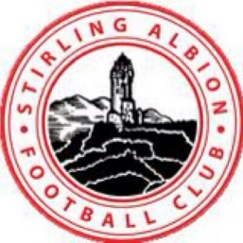

Balfron Primary School Monday Night’s 15:45-16:45

Classes aimed for kids aged 5.

12 Week Block running from 6th January- 23rd March

Bookings can be made through the Stirling Albion Website- http://www.stirlingalbionfc.co.uk/shop/

For more information contact email: community@stirlingabionfc.co.uk

