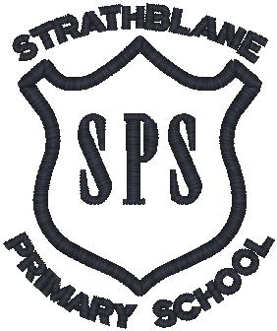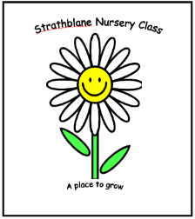

**Strathblane Primary School and Nursery Class**



**Strathblane Primary School and Nursery Travel Plan**

[](https://www.google.co.uk/url?sa=i&rct=j&q=&esrc=s&source=images&cd=&ved=2ahUKEwifuvusytXbAhVBWhQKHT-3AkkQjRx6BAgBEAU&url=https://www.keepscotlandbeautiful.org/sustainable-development-education/eco-schools/&psig=AOvVaw0SIQ_CMj56dz1OAMM-QvSm&ust=1529149075013072)**June 2018**



**Contents**

Section 1: Introduction 1

Section 2: About Our School/Nursery 4

Section 3: Location and Description of 6

Section 4: Local Transport Links and Transport Facilities 12

Section 5: School and Nursery Travel Related Polices and Practice 15

Section 6: Travel Issues 16

Section 7: Changes in Circumstances Since the Last STP 18

Section 8: Progress on Original STP 19

Section 9: Surveys and Consultation 22

Section 10: Survey Results and Analysis 23

Section 11: School/Nursery Travel Plan Working Group 26

Section 12: STP Objectives and Targets 27

Section 13: Action Plan 28

Appendix A: Public Transport Timetables 31

Appendix B: School/Nursery Travel Policies 32

Appendix C: Road Safety Video 35

##### Section 1: Introduction

**Background**

Transport Scotland defines a School/Nursery Travel Plan (STP) as *“A process whereby a school/nursery works out how it intends to make travel to and from school/nursery by children, parents, teachers and visitors, safer and more sustainable. It should identify local issues relating to the school/nursery journey and outline a series of practical steps designed to promote more active and sustainable travel choices, such as walking and cycling.”* (Transport Scotland, 2015)

Stirling Council is also supportive of School/Nursery Travel Plans (STPs) as set out in Walking and Cycling to a Healthier Stirling, published by Stirling Council in December 2016 -

*“Walking and cycling to school/nursery is important for a number of reasons, including:*

* *Improving Children’s health.*
* *Reducing the number of cars being used to take children to school/nursery.*
* *Providing children with the essential road and traffic awareness skills.*

*Stirling Council will therefore be supporting nurseries and schools in the area to ensure that everyone has a ‘live’ travel plan, in line with Council guidance …” (Walking and Cycling to a Healthier Stirling, Stirling Council, 2016).*

STPs are designed to address the problems that are an issue for an individual school/nursery.

An STP promotes sustainable and safer transport for the whole school/nursery community. A STP can result in:

* Less cars and congestion around the school/nursery site.
* Healthier, more active children, families and staff;
* Less pollution around the school/nursery.
* Safer walking and cycling routes around the school/nursery.
* Improved school/nursery grounds with provision for bicycle storage (where possible);
* A more accessible school/nursery site.
* Improved attendance and achievement.

Our STP has been created to meet the needs of Strathblane Primary School and Nurseryand we have consulted members of our school and nursery community to identify our next steps.

The aims of the STP for Strathblane Primary School and Nursery are to:

* To encourage more pupils/staff to cycle/scooter to school/nursery.
* To work with The Community Council and Strathblanefield Community Development Trust to improve off road paths to enable pupils to walk/cycle to school/nursery away from busy roads.
* To encourage more families to park and stride.
* To encourage drivers to park responsibly around the school at pick up and drop off times.

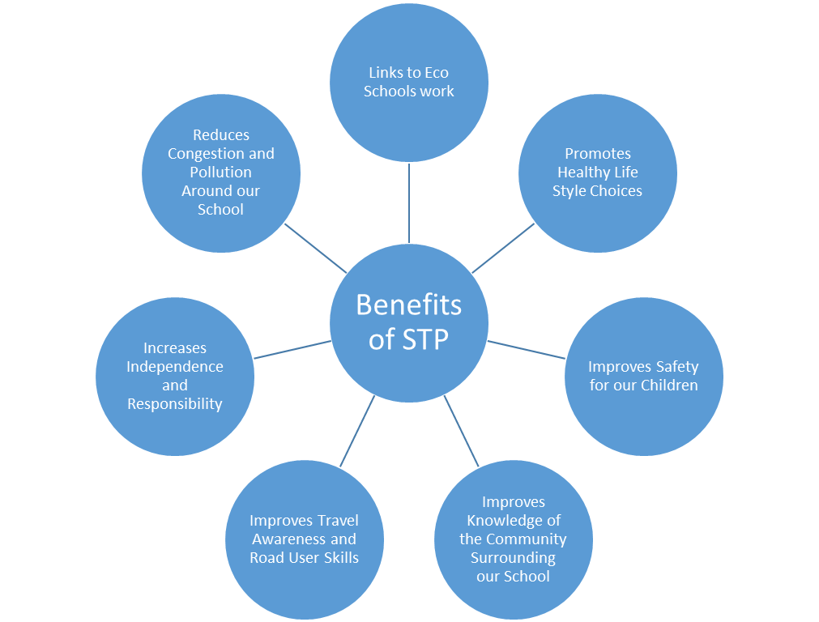

The original STP for Strathblane Primary School and Nursery was completed in May 2015.

The STP will be reviewed annually by the STP working group and the lead name responsible for this is Anne Spencer, Depute Head Teacher.

The STP was previously reviewed in November 2017. Measures implemented by the previous STP include:

* Secure funding to provide covered bike shelters with more space to park bikes and scooter.
  + Applied to Sustrans for funding to erect two covered bike shelters. One in the front playground and one in the rear playground. Achieved grant late 2016, shelters in 2017.
* Support community funding bids to improve off-road paths connecting all areas of the village to the school.
  + Met with representative of local Community Development Trust to discuss parent/pupil questionnaires.
  + Shared the proposed upgrade of paths with pupils and parents.
  + Worked with Community Development Trust to support the proposed upgrade of the path connecting Cuilt Brae to the football pitch.
* Liaise with local business and organisations to identify a suitable park and stride site.
  + Located suitable parking areas away from the school for parents to park and stride. Agreed with Kirkhouse parking area can be used by parents.
* Promote responsible parking around the school at pick up and drop off times.
  + Met with Community Police Officers and discussed the parking issues around the school.
  + Police Issued letter to parents via school and posted on school website.
  + HT spoke with Police officers and SC re signage around school-new signage added to area around school advising re parking restrictions.
  + Pupil Council facilitated a competition to design a banner to encourage parents to park safely outside the school grounds. Winning design was commercially printed and attached to the school railings.
  + Pupil Council produced a leaflet for parents about safe parking.
  + P5 met with M Vass, Community Council in class.
  + TRAVEL PLAN video made by JRSO Officers from Pupil Council and P5 with Miss Allen and shared with Community Council and SC Officers.

The contact details for the STP lead are as follows:

**Name:** Anne Spencer Depute Head Teacher

**School/Nursery:** Strathblane Primary School and Nursery

**Address:** Southview Road, Blanefield, Glasgow, G63 9JQ

**Telephone Number:** 01360 770608

**E-mail:** [strathbps@stirling.gov.uk](mailto:strathbps@stirling.gov.uk)

##### Section 2: About Our School/Nursery

**School/nursery Contact Details**

**School/Nursery:** Strathblane Primary School and Nursery Class

**Address:** Southview Road, Blanefield, Glasgow, G63 9JQ

**Telephone Number:** 01360 770608

**Website:** [www.strathblaneprimary.co.uk](http://www.strathblaneprimary.co.uk)

**School Details**

The number of children on the school roll is 199, including the nursery, as of 2018. There is the potential for additional capacity of up to 260 children.

The age range of the school children is 5 to 11 years.

**The school operates as follows:**

* **Morning Session – 9.00 am – 12.15 pm**
* **Afternoon Session – 1.15 pm – 3.15 pm**
* **Lunchtime time – 12.15 pm – 1.15 pm**

The site is open from 08:00 – 18:00 and pupils have access from 09:00 – 15:15.

**Nursery Details**

There are 24 nursery places in the morning session and 24 in the afternoon session. The age range of the nursery pupils is 3 to 5 years of age.

The nursery operates as follows:

* **Morning Session – 8.45 am – 11.55 am**
* **Afternoon Session – 12.30 pm - 3.40 pm**
* **Full Day Session - 8.45 am - 3.05 pm (8 places per day)**

The site is open from 8.45am until 3.40pm.

**School Staff Information**

Staff numbers at Strathblane Primary School total 21, in addition to a number of visitors who attend our school regularly to support learning and teaching. A break-down of our current staff includes:

* 8 full-time members of staff.
* 3 part-time members of staff.
* 6 support staff.
* 4 visiting specialists.

**Nursery Staff Information**

Staff numbers at Strathblane Nursery total 5, in addition to a number of visitors who attend our nursery regularly to support learning and teaching. A break-down of our current staff includes:

* 2 full-time members of staff.
* 3 part-time members of staff.

**Out of School/Nursery Clubs**

At Strathblane Primary School, we have many different clubs which are run by Staff and Parents.

Table 1 outlines the different use of the school building for purposes outside the school day.

1. Use of Building for Out of School/Nursery Clubs

| **NAME OF CLUB** | **CLUB ORGANISED BY** | **No. CHILDREN ATTENDING** |
| --- | --- | --- |
| Chatterbooks | Strathblane Library | 25 |
| Lacrosse | School – Mrs Bairner | 18 |
| Football P5-7 | School - Miss Allen and Mrs McCormick | 16 |
| Football P3 | Active Stirling & Parents | 22 |
| Netball | School - Miss Allen and Mrs McCormick | 30 |
| Absolute Genius Club | Parent | 25 |
| Scripture Union | School – Miss Allen | 20 |

**Extended Community Use**

**The school is used in the evenings for school events e.g. Parent Council meetings,**

**school/nursery discos.**

**School/Nursery Admissions Policy**

**Our current admissions policy can be found via the following link –** <http://my.stirling.gov.uk/services/education-and-learning/school/nurserys/school/nursery-and-nursery-places/primary-school/nursery-places>

Section 3: Location and Description of **Strathblane Primary School and Nursery**

**History of Strathblane Primary School and Nursery**

Strathblane Primary School and Nursery has been on the current site since the mid-sixties. The building is set in beautiful countryside with easy access to the natural world for environmental studies projects. Pupils enjoy spacious accommodation with classrooms, general purpose room, and hall with stage and P.E. facilities, dining area and a computer suite.

Outdoors there are generous playing areas, both hard and grassed. The Parent Council and local businesses have been very supportive in helping to raise funds to improve the school grounds. Parents, friends and the school’s pupil leadership groups have planted trees, shrubs, bulbs and other plants to enhance the environment. At recent welly days a willow den and tunnels, bottle greenhouse, pond, wildlife garden, sensory garden, herb and vegetable garden have all been added to the school grounds.

The Eco – Schools initiative encourages schools to teach children about creating sustainable environments. All classes in Strathblane Primary School are involved with “Re Using, Recycling and Reducing”. The Eco- committee has identified an action plan for the school and nursery. A Rag Bag Textile recycling container can be found in the school grounds and this is used by the community of Strathblane. The school has achieved a Bronze and Silver award and has been awarded their Green Flag.

**School/Nursery Entrances/Exits – Overview**

Figure 1 shows the main entrances and exits to the school and nursery. The school is accessed from 2 main entrances: the main entrance from Kirkburn Road and one from Southview Road. Some children come across the School playing field through the gate from the play park. Pupils are able to leave their bikes/scooters in two bike shelters, positioned at the back and also main entrances. The site is open from 08:00 – 18:00.

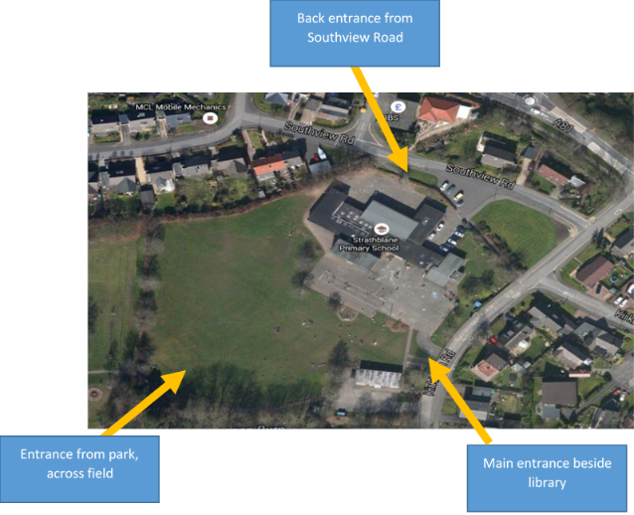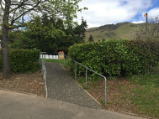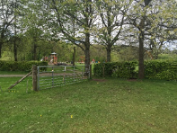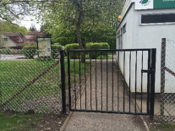

Car Park

1. School/Nursery Site Plan (Google Maps, 2018)

The school and nursery are located within a housing area. There is a small car park which is not for use by parents or pupils. This is the route used by all delivery vehicles. All but staff and visitors to the school and nursery must find parking in the village.

The primary school and nursery children are accommodated in a single building. To facilitate access, particularly for emergency vehicles, there is a short section of yellow zig zag no parking lines on Southview Road and Kirkburn Road. Parents are discouraged from parking in this area.

Pupils of the school and nursery, and parents and carers dropping off and picking up, access the playground via the main and back entrances. The majority of car users park on roads in the surrounding area.

**Surrounding Roads and Infrastructure**

As shown in Figure 2 the school is located on the corner of Southview Road and Kirburn Road. Kirkburn Road has a 20mph speed limit and there is restricted access and parking outside the school on both Southview Road and Kirkburn Road.

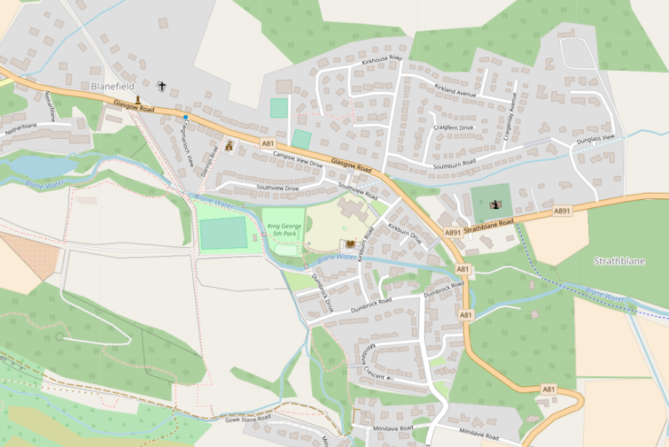

**Strathblane Primary School and Nursery**

1. Map of Surrounding Roads Strathblane Primary School and Nursery (OpenStreetMap, 2018)

**Local Highway Infrastructure**

Strathblane Primary and Nursery is situated South West of Stirling in close proximity to the A81 which provides a connection to Milngavie to the south and Drumgoyne to the north, while the A891 to the East provides a link to Lennoxtown. A map of the area can be seen in Figure 3.

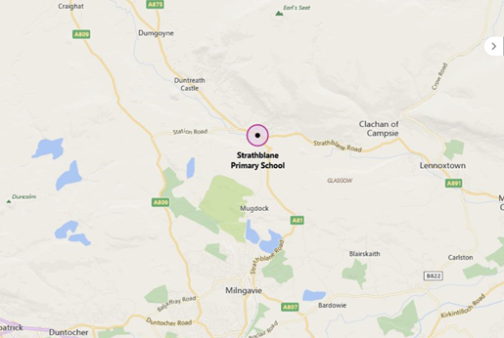

1. Local Highway and Infrastructure (Google Maps, 2018)

**Catchment Area**

A map of Strathblane Primary School and Nursery is shown in Figure 4. The majority of our pupils are from within the village, but our catchment area includes a sprawling rural expanse extending to Ballagan Farm in the East, Craigmore Cottage in the West, Dumgoyne Hill in the north and Mugdock Village in the South.

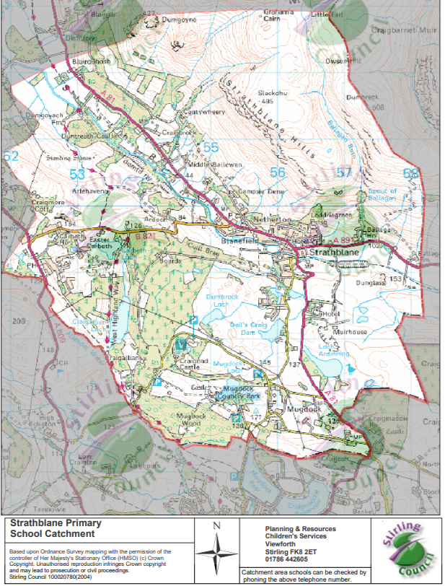

1. Strathblane Primary School and Nursery Catchment Area (Stirling Council, 2017)

Figure 5 shows where all the families live in and around the village. Each family is marked with a coloured dot. We used this to work out what percentage of children come from each area within the village. The majority of children (31%) come from the Milndavie Road and surrounding area, 18% of children come from the Ballewan and surrounding area at the far end of the village, where the footpaths are poor and 18% of the children live outwith the village and must travel by car. Another 20% live across the main road and access the school via the pelican crossing.

* Yellow – Milndavie Road and surrounding area (31%).
* Blue – Ballewan and Station Road (18%).
* Orange – Kirkhouse Road and surrounding area (20%).

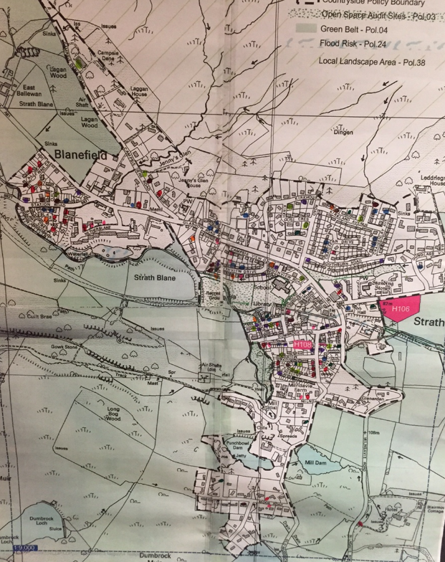

1. Location of Families in and around Strathblane Village

##### Section 4: Local Transport Links and Transport Facilities

**Local Transport Links**

**Public Bus Services**

Table 2 shows the bus services which provide access to Strathblane Primary School and Nursery. The information is correct as at May 2018. Links to individual service timetables are provided in Appendix A. The nearest bus stops are situated on Glasgow Road, approximately 215 metres from the school gate.

1. Bus Services

|  |  |  |  |
| --- | --- | --- | --- |
| **ROUTE NUMBER** | **OPERATOR** | **ROUTE** | **FREQUENCY** |
| 10A | First | Balfron - Glasgow  Via Killearn, Strathblane, Milngavie, Maryhill, Queen Margaret Dr, Gt Western Road | Monday to Friday  (except Bank Holidays) |
| 310 | First | Balfron - Milngavie  Via Killearn, Strathblane | School Days only  (except Bank Holidays) |
| B10 | First | Aberfoyle - Balfron - Glasgow  Via Killearn, Strathblane, Milngavie, Maryhill | Monday to Frida  Saturdays  Sundays  (except Bank Holidays) |
| C10 | First | Balfron - Glasgow  Via Killearn, Strathblane, Milngavie, Maryhill | Monday to Friday  Saturdays  (except Bank Holidays) |
| 515 | First | Balfron – Strathblane  Via Killearn - Blanefield | Twice per day Monday to Friday (except Bank Holidays) |
| 516 | First | Balfron – Strathblane  Via Killearn - Blanefield | Twice per day Monday to Friday (except Bank Holidays) |

**Train Services**

The nearest train station is Milngavie Station which is 4.3 miles from the village. Rail services operate to Glasgow, Motherwell, Cumbernauld and Edinburgh with a link to further timetable details provided in Appendix A.

**School Bus**

A total of 4 pupils use a taxi service which is provided by Stirling Council. These pupils are transported from Mugdock village and the surrounding area to/from the school.

**Walking and Cycling Routes**

The main walking and cycling routes which children use are highlighted and numbered in Figure 6. These include:

| **MAIN WALKING/CYCLING ROUTE DESCRIPTION** | **ROUTE** |
| --- | --- |
| **Station Road – allotment paths** |  |
| **Campsie Dene Road and Station Road (No crossings)** |  |
| **Steps on Southview Road away from Main Road** |  |
| **Kirkhouse Estate (traffic lights to cross main road)** |  |
| **Milndavie area past Co-op (no crossings)** |  |
| **Cala Estate** |  |

1. 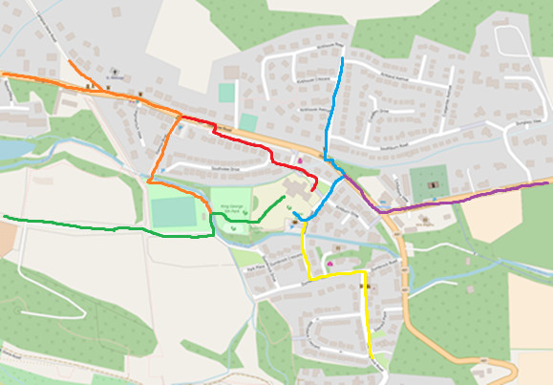Walking and Cycling Routes to Strathblane Primary School and Nursery (OpenStreetMap, 2018)

**School Crossing Patrol**

There is a no school crossing patrol, but there is a Pelican Crossing on Glasgow Road between Kirkhouse Road and Southview Road. This followed parents and the community successfully campaigning for the installation of a Pelican Crossing to improve safety for pedestrians/cyclists after the school crossing patrol was removed.

**Cycle/Scooter Facilities**

There is a covered bicycle shelter at the rear of the school and a covered bicycle shelter and an uncovered bicycle rack at the front entrance to the school.

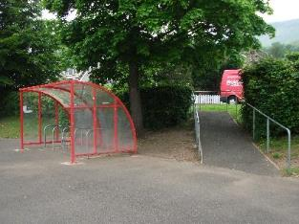Covered bicycle shelter at the rear entrance.

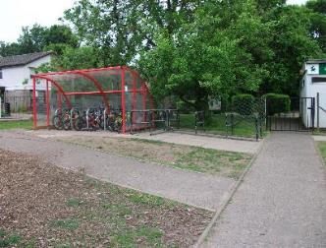Covered bicycle shelter and uncovered bicycle rack

at the front entrance.

Pupils and staff must provide their own security for the bicycles. Pupils have access to small cloakrooms where possessions can be left. Lockers are not available for pupils or staff.

**Car Parking Spaces**

There are currently 7 car parking spaces within the school grounds which are for staff and visitors use only. The size of the car park is not meeting the current demand as staff have to double park on a sloping area outside the school car park.

##### **Section 5: School and Nursery Travel Related Polices and Practice**

This section outlines school and nursery travel policies and practice at Strathblane Primary School and Nursery.

* After the removal of the school crossing patrol the parents and community successfully campaigned for the installation of a Pelican crossing to improve safety for pedestrians/cyclists.
* In 2012 and 2017 the Community Council ran a Dog fouling poster campaign in partnership with the school as this was one of the main issues affecting pavements and public space around the village. Posters were made in to banners which are displayed around the village to encourage dog walkers to be responsible and clean up after their dogs.
* In nursery children start to develop cycling skills using balance bikes before moving onto bicycles.
* Every year P6 take part in Bikeability training. There are 3 trained instructors in the school who teach children how to travel safely on their bikes.
* In 2017-18 the Pupil Council agreed that including two Junior Road Safety Officers (JRSO’s) on the Council would be beneficial as discussions could be shared during meetings. The JRSO’s worked alongside Primary five in February 2018 to produce a video with Miss Allen for presentation at the Community Council. This focussed on the travel plane and achievements to date.
* PC Craigie visited the school in January and February 2018 to deliver Road Safety talks in Nursery and to the whole school at assembly. He is a regular visitor to the school.
* We have very active Pupil Council, Sports Council and Eco Councils who have all focused on different aspects of health and wellbeing including safe travel.
* We have a Safe Routes to School policy giving advice and information on safe travel to and from school and safe ty in the school grounds - updated January 2018.
* In 2018 M Vass of the Community Council visited P5 pupils and Miss Allen in school and heard the children’s concerns about travel and safety in the village.
* We undertake the annual Hands up Survey in school every year.
* We have taken part in the cycle to school campaigns over the last 5 years.
* In 2016-17 Miss Alexander and pupils applied for funds from Sustrans and our Parent Council to purchase two covered bike shelters that are now available for use by all children in the front and rear areas of the school.

Copies of existing school and nursery travel related policy is provided in Appendix B.

##### Section 6: Travel Issues

This section outlines key travel issues in relation to the school and nursery. Identification of the issues has been informed by work where we conducted consultations, including parent surveys in October 2017 and meetings with representation from pupils/parents/staff/local community during October and November 2017. Our pupils have also undertaken speed surveys with our local community Police Officer in January 2018.

Here are the key issues identified through these activities, categorised as follows:

**Speeding Vehicles**

* Cars travelling too fast - SPEED was a big issue that make a lot of the children feel unsafe. This was the speed of cars outside the school/nursery but also around their homes.
* There are no road signs to tell cars to slow down near our school/nursery.
* A speed survey with the local police identified six speeding vehicles passing the school gate over a one hour period.

**Volume of Vehicles**

* There were three areas that were highlighted as very busy with very few safe crossing spots – junction of Campsie Dene Road and Glasgow Road, junction of Glasgow Road and Campsie Road and the area around the Co-op on Old Mugdock Road.

**Composition of vehicles**

* Different types of vehicles use in the streets around Strathblane Primary School and Nursery Class. These include coaches, recycling vehicles, vans and cars. Some of these vehicles are large and are accessing streets which are narrow, especially directly outside the school/nursery grounds.

**Other**

A parent/carer consultation undertaken in October 2017 highlighted the following key points:

* There is a lot of unpredictable parking near the school/nursery where children are trying to cross.
* Lack of traffic calming measures on the main road.
* Only one crossing on the main Glasgow Road.
* Speeding traffic.
* Lack of time due to onward travel to work.

When asked what would encourage parents to walk their children to school/nursery, the two main answers were reduced speed of traffic and safer crossing areas.

Other issues, include:

* Signage around the school/nursery.
* Availability of crossing facilities.
* Parents parking.
* Surrounding environment.
* Staff parking.
* Drop-off/pick-up.
* Cycle infrastructure around the school/nursery.

A link to a travel plan video is enclosed in Appendix C. This was prepared as part of the last STP, but highlights a number of issues which are still a concern.

**Travel Issues Identified in previous travel plan**

No pavement on Cuilt Brae – 60mph traffic and tight bends. Access route from Blane Crescent area to allotments.

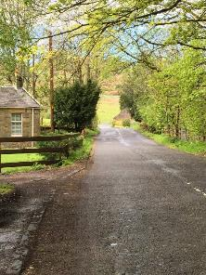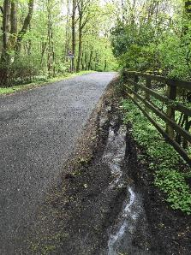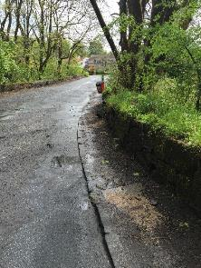

Blane Crescent and Glasgow Road – Narrow Pavements

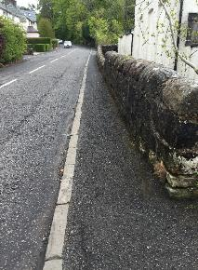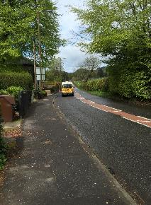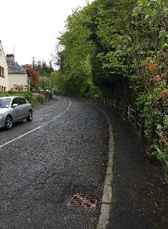

##### Section 7: Changes in Circumstances Since the Last STP

Since the last STP the capacity in the nursery has risen from 20 to 24.

##### Section 8: Progress on Original STP

Table 3 below provides details of progress in achieving the actions and targets of the previous STP Action Plan published in 2017.

1. STP Travel Action Plan Progress

| **ACTION**  ***What will be done to achieve the objective and target set?*** | **TARGET**  ***A specific point to reach within a certain time?*** | **RESPONSIBILITY**  ***Who will be responsible for achieving this action?*** | **PROGRESS UPDATE**  ***To date what progress has been made?*** |
| --- | --- | --- | --- |
| Apply to Sustrans for funding to erect two covered bike shelters. One in the front playground and one in the rear playground. | Secure funding to provide covered bike shelters with more space to park bikes and scooters. | Eco Group & Miss Allen | December 2016  ACHIEVED-Grant late 2016.Bike shelters 2017 JENNIFER ALEXANDER and Parent council. |
| Meet with representative of local Community Development Trust to discuss parent/pupil questionnaires.  Share the proposed upgrade of paths with pupils and parents.  Work with Community Development Trust to support the proposed upgrade of the path connecting Cuilt Brae to the football pitch.  Support Strathblanefield Community Development Trust to upgrade the path through the Glen. | Support community funding bids to improve off-road paths connecting all areas of the village to the school. | Miss Spencer & Mr Breslin (Parent Council)  Miss spencer-Mr Breslin, Mr Hutton and one other male rep | June 2015  ACHIEVED  June 2016  ACHIEVED  ACHIEVED  June 2017  June 2017  This action has been put on hold at the moment. |
| Locate suitable parking areas away from the school for parents to park and stride. | Liaise with local business and organisations to identify a suitable park and stride site | Junior Road Safety Officers with Miss Spencer | January 2016  DISCUSSION WITH KIRKHOUSE-AGREED PARKING AREA CAN BE USED BY PARENTS-INFORMATION SENT OUT-A SPENCER  Newsletter reminder that park and stride available from Kirkhouse 2017 |
| Meet with Community Police Officers to discuss the parking issues around the school. | Promote responsible parking around the school at pick up and drop off times. | Pupil Council, Mr Viola and Community Police Officers | October 2016  ACHIEVED-HT  December 2015 |
| HT met with Community Police Officers to discuss concerns about parking and safety around school –requested police presence and communication to parents  Police Issued letter to parents via school and posted on school website. |  |  | January 2017  ACHIEVED-HT  January/February 2017 |
| HT spoke with Police officers and SC re signage around school-new signage added to area around school advising re parking restrictions. |  |  | ACHIEVED  March 2017 |
| Pupil Council to facilitate a competition to design a banner to encourage parents to park safely outside the school grounds. Winning design to be commercially printed and attached to the school railings. |  |  | ACHIEVED-POSTER COMPETITION AND POSTERD DISPLAYED-CLASS TEACHERS |
| Pupil Council to produce a leaflet for parents about safe parking. |  |  | April 2016  ACHIEVED AND SENT OUT-PUPIL COUNCIL AND MR VIOLA |
| P5 meet with M Vass, Community Council in class. |  |  | November 2017  ACHIEVED |
| TRAVEL PLAN video made by JRSO Officers from Pupil Council and P5 with Miss Allen and shared with Community Council and SC Officers. A link to a copy of the video can be found in Appendix C. |  |  | ACHIEVED JANUARY 2018  CC received funding from SC as a result |

##### Section 9: Surveys and Consultation

This section outlines consultation activities undertaken and the results. This includes consideration of pupil and staff modes of travel to school. Table 4 outlines the consultation activities undertaken.

1. Survey/Consultation Summary

|  |  |  |  |
| --- | --- | --- | --- |
| **WHO WAS CONSULTED?** | **WHAT WERE THEY CONSULTED ABOUT?** | **WHEN** | **HOW DID THE CONSULTATION HAPPEN?** |
| Children | Travel to school/nursery | September 2017 (annually) | Hands Up Scotland Survey. |
| Parent/Carers | School travel concerns | October 2017 | Survey distributed to families. |
| Community Council | School’s concerns about pupils’ safety when travelling around the village. | Spring 2018 | DHT met with members of the Community Council and Community Development Trust. |
| Community Development Trust | School’s concerns about pupils’ safety when travelling around the village. | Spring 2018 | DHT met with members of the Community Council and Community Development Trust. |
| Pupils in Primary 5 | What the children thought the Community Council could do to improve the village. | November 2017 | School visit from 2 Community Council members to Primary 5. |
| Children | Safer routes to school. | Monthly | Pupil Council representatives consulted their own class and fed back at Pupil Council meetings. |
| P5 JRSO | How can we let people in the community know about actions around safe routes to school and travel planning. | January 2018 | The children created a video which was presented at a Community Council meeting. |

##### Section 10: Survey Results and Analysis

**School Travel – Pupils**

A whole school Hands Up Scotland Survey (HUSS) was conducted in 2017. The children were asked about how they came to school on the particular day of the survey. The results shown in Figure 7 illustrate that the majority of primary children (41.1%) walk to school. Followed by 28% driving all the way to school and 14.9% Park & Stride. Full results can be seen in Figure 7 below and further discussed below.

1. School Pupil Mode of Travel (Sustrans, 2017)

**Driving**

In the 2017 HUSS 28% of children were driven all the way to school on the day of the survey. The main reason given for this is that parents do not have time to walk and need to leave for work.

**Park and Stride**

Also, in 2017 the HUSS reported 14.9% of children indicated that Park and Stride was how they travelled to school which means they drive most of the way, parking nearby and then walk the rest of the distance to the school gate.

**School Pupil Travel Distance**

The majority of school children live in the immediate area as illustrated in Table 5 by the fact that 79% of children live under one mile from the school. A further 5% of pupils live between one and two miles from the school.

1. Pupil Distance from School

|  |  |
| --- | --- |
| **DISTANCE** | **% CHILDREN** |
| Live less than one mile from Strathblane Primary School | 79% |
| Live between one and two miles from Strathblane Primary School | 5% |

**Nursery Travel – Pupils**

A nursery Hands Up Scotland Survey (HUSS) was conducted in 2017. The children were asked about how they came to nursery on the particular day of the survey. The results shown in Figure 8 illustrate that the majority of nursery children (50%) walk. Followed by 35% driving all the way to nursery. Full results can be seen in Figure 8 below.

1. Nursery Pupil Mode of Travel (Sustrans, 2017)

**Historic Pupil Travel Data**

Table 6 shows historic pupil travel data from the Hands Up Scotland Survey (HUSS). This shows that for the period 2011 to 2016, the majority of children walked to school (approximately 52%), although this has been decreasing over the years. There has also been an increase in the number of children travelling to school by car from nearly 15.9% to 35.1% and an increase in the number of children that Park and Stride from almost 5.8% to 13.7%. Children who cycle and Scoot/Skate to school has also increased since 2011, although in 2016 the number of children cycling has decreased slightly from around 10.9% in 2015 to 6.5% in 2016. A similar trend can be seen for Scoot/Skate, as shown in the table below.

1. Historical School Pupil HUSS Data 2008 – 2016 (Sustrans, 2016)

|  |  |  |  |  |  |  |  |  |  |
| --- | --- | --- | --- | --- | --- | --- | --- | --- | --- |
| **Mode of Travel (%Children)** | | | | | | | | | |
| **Year of Survey** | **Walk** | **Cycle** | **Scoot/ Skate** | **Park & Stride** | **Driven** | **Bus** | **Taxi** | **Other** | **Total No. Children** |
| **2011** | 70.3% | * | * | 5.8% | 15.9% | 3.6% | * | 0.0% | 138 |
| **2012** | 62.0% | 3.5% | 3.5% | * | 25.4% | 4.2% | 0.0% | * | 142 |
| **2013** | 47.9% | 10.7% | 10.7% | 7.9% | 19.3% | * | * | 0.0% | 140 |
| **2014** | 49.7% | 10.9% | 6.8% | 4.1% | 26.5% | * | * | 0.0% | 147 |
| **2015** | 46.7% | 10.9% | 6.7% | 6.1% | 26.1% | 3.0% | * | * | 165 |
| **2016** | 36.9% | 6.5% | 5.4% | 13.7% | 35.1% | 2.4% | * | * | 168 |

*Supressed data noted in HUSS results

In 2015, it was recorded that the majority of children (40.9%) attending the nursery cycled, followed by 27.3% walking to nursery, results can be seen in Table 7.

1. Historical Nursery Pupil HUSS Data 2015 (Sustrans, 2016)

|  |  |  |  |  |  |  |  |  |  |
| --- | --- | --- | --- | --- | --- | --- | --- | --- | --- |
| **Mode of Travel (%Pupils)** | | | | | | | | | |
| **Year of Survey** | **Walk** | **Cycle** | **Scoot/ Skate** | **Park & Stride** | **Driven** | **Bus** | **Taxi** | **Other** | **Total No. Pupils** |
| **2015** | 27.3% | 40.9% | * | 0.0% | * | 0.0% | 0.0% | 0.0% | 22 |

*Supressed data noted in HUSS results

**Parent/Carer Consultation**

A parent/carer consultation undertaken in October 2017 highlighted the following key points:

* There is a lot of unpredictable parking near the school/nursery where children are trying to cross.
* Lack of traffic calming measures on the main road.
* Only one crossing on the main Glasgow Road.
* Speeding traffic.
* Lack of time due to onward travel to work.

When asked what would encourage parents to walk their children to school/nursery, the two main answers were reduced speed of traffic and safer crossing areas.

**Mode of Travel – Staff**

## Points relating to staff travel include:

* Four members of staff live locally and walk to school.
* Nineteen members of staff live five miles or more away from the school and travel in cars as lone drivers.
* All members of staff said that the size of the car park is not meeting the current demand as they have to double park on a sloping area outside the school car park.

##### Section 11: School/Nursery Travel Plan Working Group

The STP Working Group comprises representation from:

* Strathblane Primary and Nursery School staff.
* Parent representatives.
* Pupil representatives.
* Representatives of the local community.

The group meets during the school year. Table 8 summarises the meetings that have taken place.

1. STP Working Group Meeting

|  |  |  |
| --- | --- | --- |
| **DATE OF MEETING** | **ATTENDEES** | **PURPOSE OF MEETING** |
| November 2017 | Community Council  Primary 5  JRSO  Staff representative | For the Community Council to gather the views of the children and staff on what could be improved in the village and how the two groups could work together. |
| January 2018 | Community Council  Parents  Members of the community  Police  Stirling Council representative | To share the children’s views on road safety around the village through a video the children had made in school - See Appendix C. |
| Spring 2018 | Community Council  Community Development Trust  DHT | To discuss the school and local groups concerns about pupils’ safety when travelling around the village. |

##### Section 12: STP Objectives and Targets

The objectives and targets of our STP are set out below.

|  |  |
| --- | --- |
| **OBJECTIVE** | **TARGET** |
| Reduce speed of vehicles where Campsie Dene Road and Glasgow Road meet. | Increased signage and traffic calming measures where Campsie Dene Road and Glasgow Road meet.  School and Community Council have identified an increased number of pupils travelling to school from Campsie Dene Road. |
| Create a safer route for pupils and the local community to walk to the local care home. | A safer route for pupils and the local community to walk to the local care home to support intergenerational visits – narrowing of the bridge and a widening of the pavement at Cuilt Brae. |
| Reinforce responsible parking. | Increased signage around the school to reinforce responsible parking. |

##### Section 13: Action Plan

This section sets out our Action Plan to achieve the objectives and targets of the travel plan.

**Objective:** Reduce speed of vehicles where Campsie Dene Road and Glasgow Road meet.

**Target:** Increased signage and traffic calming measures where Campsie Dene Road and Glasgow Road meet.

**Baseline:** School and Community Council have identified an increased number of pupils travelling to school from Campsie Dene Road.

| **ACTION**  *(What will we do?)* | **RESPONSIBLE** *(Who will manage the action?)* | **TIMESCALE**  *(Action completed by?)* | **SUCCESS CRITERIA**  *(What do we want to achieve for each action?)* |
| --- | --- | --- | --- |
| School to discuss with the Community Council and Stirling Council steps to progress work to address concerns about vehicle speeds at Campsie Dene Road/Glasgow Road junction. | School and Community Council to work with Stirling Council Road Department/Sustrans requested to progress this work. | TBA | Increased signage and traffic calming measures where Campsie Dene Road and Glasgow Road meet. |

**Objective:** Create a safer route for pupils and the local community to walk to the local care home.

**Target:** A safer route for pupils and the local community to walk to the local care home to support intergenerational visits

**Baseline:** School and Community Council have identified the need for a safer route to the local care home to allow pupils to travel to the care home away from the main road.

|  |  |  |  |
| --- | --- | --- | --- |
| **ACTION**  *(What will we do?)* | **RESPONSIBLE** *(Who will manage the action?)* | **TIMESCALE**  *(Action completed by?)* | **SUCCESS CRITERIA**  *(What do we want to achieve for each action?)* |
| School to discuss with the Community Council and Stirling Council the next steps to progress work to create a safer route for school pupils as well as safer access to the local care home. | School and Community Council to work with Stirling Council Road Department /Sustrans requested to progress this work. | TBA | Narrowing of the bridge and a widening of the pavement at Cuilt Brae. |

**Objective:** Reinforce responsible parking by increasing signage around school.

**Target:** Increased signage around the school to reinforce responsible parking.

**Baseline:** School and Community Council have identified irresponsible parking around the school which poses a safety risk to pupils.

| **ACTION**  *(What will we do?)* | **RESPONSIBLE** *(Who will manage the action?)* | **TIMESCALE**  *(Action completed by?)* | **SUCCESS CRITERIA**  *(What do we want to achieve for each action?)* |
| --- | --- | --- | --- |
| Reinforce responsible parking by increasing signage around school. | School, community Council and Police. | TBA | Increased signage around the school to reinforce responsible parking. |
| JRSO and children produce posters to highlight safer and responsible parking. | JRSOs. | To be undertaken in the new school term. | Increased signage around the school to reinforce responsible parking. |

**Section 14: STP Monitoring and Sign-Off**

In the future, we will review our plan annually to agree if we have met our targets or if we need to set new ones. This will be completed on an annual basis at the start of each school session.

* The next **Hands up Scotland Survey** (HUSS) will take place in **September 2018**.
* The next **School pupil/staff transport survey** will take place in **October 2018**.
* **Annual STP Review** date – **September 2019**.
* **Full STP Review** date – **September 2020**.

Strathblane Primary School and Nursery Class is committed to review/revise the STP with changes which effect travel to our school/nursery and the STP is signed on behalf of our school/nursery by:

|  |  |  |  |
| --- | --- | --- | --- |
| **STP LEAD** | **DESIGNATION** | **SIGNATURE** | **DATE** |
| Anne Spencer | Depute Head Teacher |  | 31/05/18 |

Our STP can be viewed on our school website at [www.strathblaneps.com](http://www.strathblaneps.com).

##### Appendix A: Public Transport Timetables

**Bus Services**

Timetable information for the bus services can be found here:

<https://www.firstgroup.com/south-east-and-central-scotland/plan-journey/timetables/?operator=25&service=STRATHBLANE&page=1&redirect=no>

**Rail Services**

Further details about the rail services to/from the nearest station at Milngavie can be found at - https://www.scotrail.co.uk/plan-your-journey/stations-and-facilities/mln

##### Appendix B: School/Nursery Travel Policies





Strathblane Nursery Class

A place to grow

Strathblane Primary School and Nursery Class Safe Routes to *School Policy*

*The safety and wellbeing of our children is everyone’s responsibility.*

Road Safety is part of the Health and Wellbeing Programme for the School and Nursery and is taught throughout the year.

The school has Junior Road Safety Officers as part of the Pupil Council and they are encouraged to raise discussion about any issues of safety around the school.

Regular messages are posted on the School Website and Newsletters encouraging parents to park sensibly, heed signs, park and stride, walk and cycle to school and the ‘safe use of bicycles and scooters’ in the school grounds.

Children are encouraged to choose healthier routes to school i.e. walking or cycling and the school undertakes cycle training and bike maintenance programmes.

The Nursery Class supports parents with teaching their children ‘how to ride a bike’ with regular opportunities to use balance bikes before progressing to wheeled bikes.

The school provides enclosed grounds with closed access gates at all entry areas to ensure the safety of children and covered bike shelters in both the front and back areas of the school grounds.

There is access for bicycles to enter the school grounds via the main back and front pedestrian pathways.

Signage has been increased around the school to raise awareness of responsible parking and children’s safety and the children have made posters and signage for this purpose.

The school holds regular discussions at assembly about ‘Being Safe’, including Road Safety and local Police are encouraged to visit classrooms, nursery and school to support this.

Walking To School

Children should be accompanied by a responsible adult until an age where parents feel their child is mature enough and equipped with the skills to walk without an adult presence.

Children, supported by parents, should always be guided to use the appropriate access routes from home to school i.e. pavements and pedestrian crossing. Parents should demonstrate the use of these as role models.

Children are taught the Crossing Code in School and this should be used by parents also to ensure children check before crossing, walk away from the pavement edge, wear clothes that allow you to be seen in the dark etc.

Driving to School

Adults drive cars, children do not therefore, it is the responsibility of the adult delivering or collecting children from school/nursery to-

* Ensure children have the appropriate safety seats and seatbelts
* Drive and park safely and within the law.
* Take account of conditions, speed limits and restrictions on roads and in particular around school.
* Park responsibly, avoiding parking in areas that have lines or markings pavements or areas that restrict vison.
* Demonstrate safe and courteous behaviour as a driver.

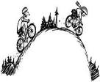Cycling To school

Parents and Carers are responsible for ensuring the road worthiness and size appropriateness of the bicycle used by their child.

Parents and Carers should ensure children wear a cycle helmet and clothing that ‘can be seen’ by traffic and is appropriate for the conditions

Children should have a responsible adult with them when cycling to school until they are mature enough and have the skills to cycle unescorted.

Children should follow the crossing code whether on bike or foot and parents/carers should regularly remind children of this to reinforce the messages being given in school and nursery.

Children should only enter school grounds via pedestrian pathways if the area is clear of adults or children walking. Otherwise they should dismount.

Free cycling (skateboarding, space hopping, pogo jumping, etc.) is not permitted in the school grounds after 8.45 and before 3.15 (or later if there is an after school club in the grounds) to ensure there are no accidents.

Children should park bikes etc. in the bike shelters provided prior to the school bell.

Please note-Personal property is a personal responsibility therefore all items left in the shelters during the school day should be secured.

School Car Park

Staff must ensure their car is appropriately parked avoiding access spaces to the kitchen, fire exits and entry routes for emergency vehicles.

Staff only are permitted to use the internal school car park. Staff should REVERSE Park into spaces.

The external parking area is for staff and visitors to the school to park therefore parents and carers should avoid this area so that staff arriving at/leaving work have clear access.

The external area should also be REVERSED into unless there is a turning space to the front in which a car can safely be turned.

Staff must take extra care when entering or leaving the car park or external parking area between 8.30 and 9.00 and 3.00 and 4.30 as children are likely to be around after school/clubs.

Particular care should be taken when crossing over the area that has pavement either side on the exit from the school car park.

Parents, carers and children are regularly reminded not to be in the vicinity of the car park and external parking area and not to access the school via the gate in the car park. There is a safe route provided from the pavement directly into the rear school grounds which also has ramp access for prams and wheelchairs.

Please support our School and Nursery in ensuring the safety and wellbeing of our children.

Better safe than sorry!

Updated January 2018.

##### Appendix C: Road Safety Video

<https://youtu.be/C7vzNEBdmTo>