Strathblane Primary School

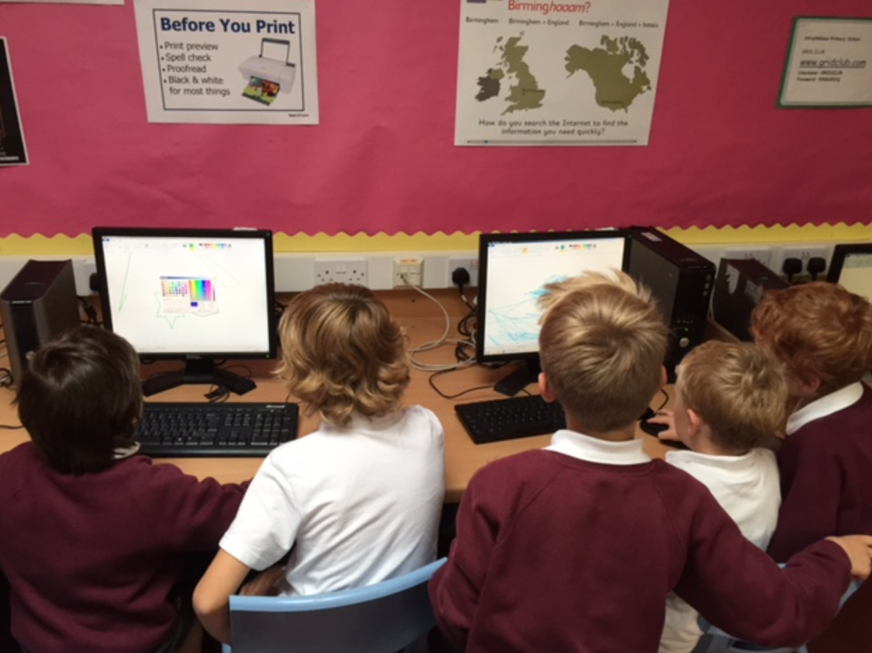

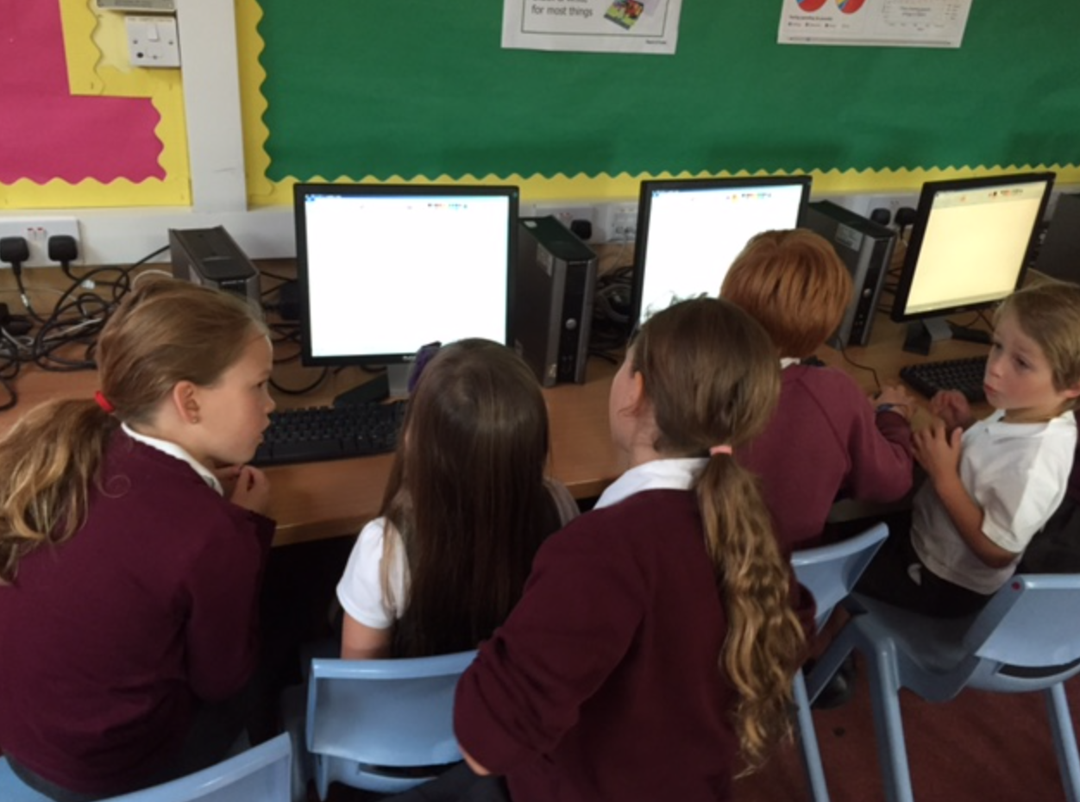

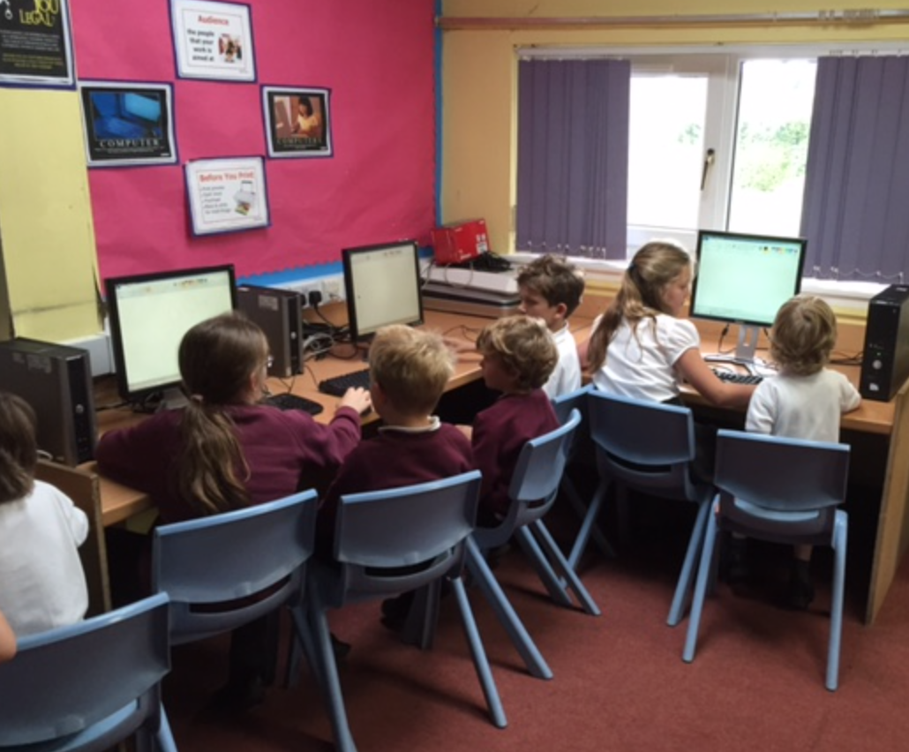

ICT Survey Results –
Parents, Pupils and Staff

October 2015

Contents
Staff Results – Pages 2-5
Parents Results – Pages 6-9
Pupil Results Pages 9-11

___________________________________________________________

Staff ICT survey Results (Teaching Staff, Support Staff and SMT)

1. Are there any areas which you would appreciate training in with regards to ICT in the school?

- Sound System x 7
- Whiteboards and Active Inspire x 3
- Tablets and Apps x 2
- Would appreciate training in general computing to help the children.
- Linking laptop to projector
- Glow
- Effective use of projector and screen for assemblies
- Use of ICT to support different curricular areas.
- Skills Progression x 2
- Programmes to display information
- Good sites and lists of resources
- Plasma x 3
- Producing labels and banners for display

2. Which pieces of ICT equipment are most valuable to you and what do you use them for?

- ICT Suite - maths challenges, research, typing practice, educational games, internet
- Whiteboard - Display info, videos, notes, Jolly Phonics, Interactive Teaching Activities, Maths 100 square, presentations, daily routines, Success Criteria and Learning Intentions
- Computers - maths challenges, redrafting, games, typing, PowerPoints, school emails, vantage point, planning
- Camera - video presentations, photo evidence
- Tablets- video and review of PE performances (peer feedback)
- Easispeak - Recording of reading for self assessment, dictation of written work for ASN
- Plasma and Projectors - Presentations and Assemblies
- Own laptop for SI meetings

3. What skills do you expect the children coming in to your class to have?

Nursery | Skills vary for different children depending on home experiences
P1 | Use of paint, use of mouse, use of familiar websites, use of roamer
P2 | Log on, ability to locate keys, open programmes, take pictures, switch computer on and off correctly, keyboard layout and search tools
P3 | Use features of Word, PPT, paint, Use Google, Log on and off, find websites, play age appropriate games
P4 | Basic typing skills, log on and off, mouse control, locate programmes, locate files and save work, capture images on cameras and tablets, use whiteboard pen for writing and selecting
P5 | Log on and off, shut down, open Word and internet, take pictures using cameras
P6 | Use mouse and keyboard, log on and off, shut down, OS terms (desktop, close, minimise, browser, tab, window), difference between save and save as
P7 | Whiteboards - how to use tools on activ inspire, powerpoints - slides, animation, text box, inserting film etc, Word - saving, creating, textbox word art, animation

4. What skills would you expect the children in your class to have developed by the end of the school year?

Nursery
P1 | Log on and off, access useful websites (top marks, cbeebies), find letters on keyboard, change font size etc., PP presentations, copy and paste
P2 | Use features of Word, PPT, paint, Use Google, Log on and off, find websites, play age appropriate games
P3 | save documents, locate documents, copy/paste images
P4 | enhanced all previous skills, open and save files, more advanced features of Microsoft Office
P5 | Manipulating texts and images, Use of search engines
P6 | consolidate previous outcomes, familiarity with Word, PPT and excel, Glow and O365 one drive, Fluent typing, use of keyboard shortcuts
P7 | Animation, creating, saving and editing film footage, confident with whiteboard/activ inspire, good standard of PowerPoint

- What are your biggest frustrations when using the technology in the school?

Speed of internet connection |  | 3
Speed of Computers |  | 11
Lack of Wifi |  | 4
No. of Computers |  | 2
Lack of Portable ICT |  | 1
Not being able to help children due to lack of ICT knowledge |  | 1
Temperamental Equipment |  | 6
Whiteboard bulbs |  | 3
Infrastructure |  | 1
Outdated Technology |  | 1
New Systems appear to make things more difficult |  | 1
Speed of internet connection |  | 3
Speed of Computers |  | 7
Lack of Wifi |  | 3
No. of Computers |  | 2
Lack of Portable ICT |  | 1
Not being able to help children due to lack of ICT knowledge |  | 1
Temperamental Equipment |  | 5
Whiteboard bulbs |  | 2
Poor Infrastructure |  | 1

- If funding were to become available what would you prioritise with regards to technology?

In order of preference: Wifi, Desktops, IPads, laptops, whiteboards, server upgrade, audio and video equipment.

- Any other comments?

- Priorities vary according to funds. With limited money I'd like to try and get as much as possible, though prefer portability (IPad with Bluetooth keyboards would be awesome but not worth the money just to get a handful.)
- IPad can be used for AV (commented by 3 members of staff)
- I expect children across the school to have access to all available technology and programmes to enhance and support learning. The key is not just access to technology but the teaching and development of skills.
- As an educator my greatest frustration is that we are "teaching for the 21st century" using very limited and outdated technology yet there is a ZERO budget to improve this and no strategic plan, that I am aware of, by the authority to upgrade the resources available in schools. It appears to be down to fundraising.
- It would be helpful to have a basic skills series to follow - an updated Smart Learning programme.
- I would welcome any in-house training in ICT skills especially with things I would use day to day.
- The nursery could really do with a technology upgrade.

Parent Results of ICT survey

1. What class is your child in?

2. How confident are you in the use of ICT?

3. Which of these do you have in your home?

4. How do you prefer to receive information from the school?

5. How often do you check the school website?

6. How do you feel about children bringing their own equipment to school?

66% of respondents would not be happy with their children bringing their own equipment.

Additional comments:
- I don’t want my children bringing own equipment unless you pay for the repairs.

- I don’t want my children bringing their equipment because they would lose it.

- Not all pupils would have their own equipment and it is very expensive.

- I don’t believe children should be asked to bring their own tablets etc to school - not all families can afford tablets or even Ipads - may lead to comparisons being made. Also the risk of damaging is also a concern.
- I would not be open to my children bringing their own equipment to school as my child does not have this equipment.

- I would be hesitant about my child bringing a laptop/ipad to school for a number of reasons, one being the safety of the equipment due to the cost and the responsibility of doing this.
- My children do not have their own equipment.
- Yes I would be ok with him bringing his own equipment but he doesn’t own any.
- Yes to bringing own equipment, however, I would want to ensure that there were safety rules in place and that all children have equal access to equipment.

7. Would you value training in the use of Technology?

61% of respondents would value training, 12 people specifically mentioned Internet safety.

8. Any Additional Comments?

- I am not very good with computers so would love to know how to use them to help my children at home.

- I would also like my children to get training on Internet safety.

- It is a concern that children without computer access at home can be disadvantaged. There has to be a balance. I do appreciate that my son is motivated to do his homework on the computer but not all homework should be electronic.

- I am all for ICT development, however, handwriting skills are also important. At Balfron HS most coursework continues to be handwritten, therefore, children need to have a high standard of written work.

- I would like to understand how many hours per school week, my child spends on a screen or electronic device.
- Some of the websites used as part of their homework do not appear to be IPad friendly.

- My child mostly uses the links provided through school for web browsing and educational games. I would be happy to receive more.

____________________________________________________________

Pupil ICT Survey Results

- How many hours a week do you spend using technology?
These are the average amount of hours that respondents spent using technology.
Games Console | 1-2 hours
Ipad or Tablet | 2-3 hours
Kindle or E-reader | 1 hour
Desktop or Laptop | 1 hour
Television | 10+ hours
Smartphone | 2-3 hours

- What programmes or websites do you use at home?
In order of popularity (10 or more): Youtube, Minecraft, Sumdog, Cool Maths Games, TopMarks, Cbeebies, Jolly Phonics, Khan Academy, google.

Other sites that fewer children use: Netflix, Skype, Imovie, Manga High, Clash of the Clans, Glow, Excel, Powerpoint, Spotify, Subway Surfers, Word, Friv, Nitro Type, BBC Iplayer, Lego Games, CBBC, Hill Climb Racing, Match n Spell, Copy Cat, Fruit Ninja, Animal Puzzles, Angry Granny, Angry Birds, Safari, Temple Run 2, Nick Jr website,My Horse, How to Train your Dragon Games, I can Cook, Studyladder, Lego Ninjago, Facebook, My Story, Sophia the Fish, Crossy Road, Let's Play, Sketchbook, Ebay, Fifa 15, CBBC, Star Gazing App, Northern Lights App, Cut the Rope, Noughts and Crosses, Fashion Story, Pet Shop Story, Animal Crossing, Online Shopping Pages, Woodlands Jr.

- What programmes do you use at school?

Cbeebies, Topmarks, Sumdog, Word, Studyladder, PowerPoint, Glow, Khan Academy, Manga High, Excel, Google, Twig, Cool Maths Games, Youtube, Sums for the Brain, Athletic Stretches, CBBC, Paint, Fun 4 Kids, Number Jacks, Fun 4 the Brain, Incas, NitroType

- Which of these things would you most like for our school?

In order of preference for the children – Wifi, ICT Desktops, Laptops and IPads (equal votes), Video equipment, Whiteboards and finally audio equipment.

- Any other comments?

- The equipment that I most want for the school depends on what the teacher needs and what they believe will help the most with their teaching.
- School seems already well kitted out with IT.
- Use of IPads/laptops and WiFi could provide flexi working environment for kids/teachers.
- I don’t really feel I know how much equipment you already have in school to answer this correctly.
- No idea what equipment the school needs, happy for this to be informed by the demands of CfE.
- Don’t know what is needed most for ICT equipment in the school.

