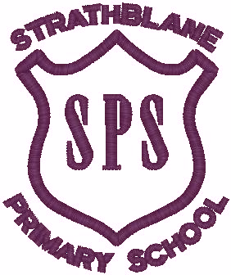 Strathblane Primary and Nursery Class Improvement/Recovery Plan 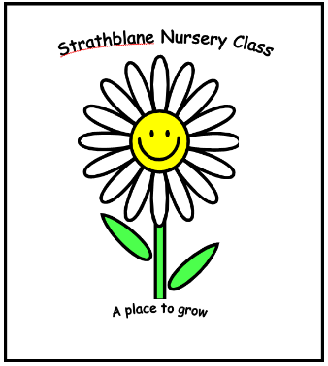
2022-23

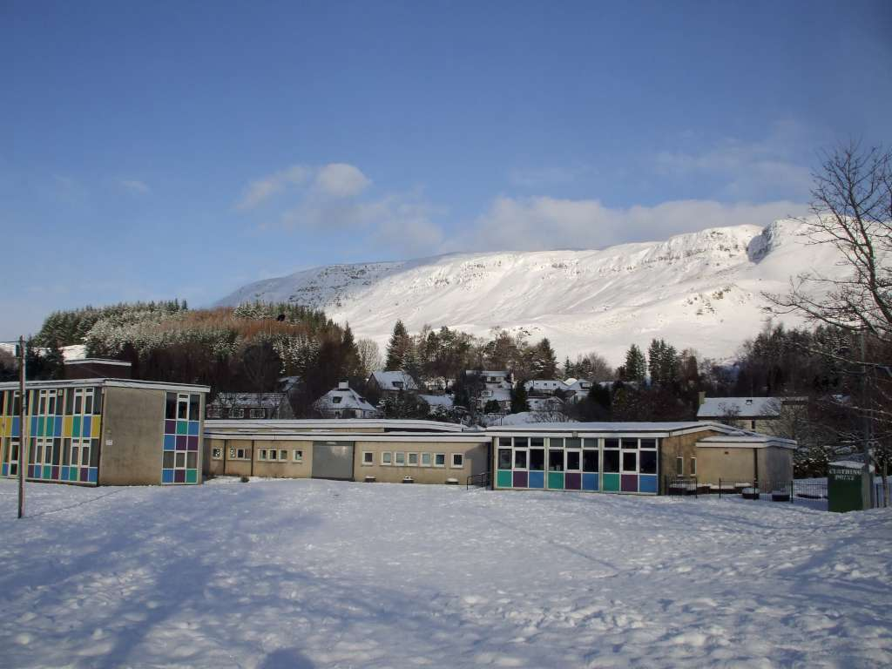

Vision

‘It Takes A Village To Raise A Child.’

Partnership working is key to achieving best outcomes for our children.

Motto

‘Be all you can be!’

Our children are encouraged to be aspirational through an ethos of achievement and high expectations.

Values

Our shared values underpin all that we do in school, and beyond.

- Honesty
- Respect
- Responsibility
- Co-operation
- Fairness

Aims

Our aims are linked to Stirling Council aims, the National Priorities and Legislation for Education. The work we do reflects Stirling Council’s Mission Statement,

“Improving Life through Learning”.

To foster in our children a lifelong love of learning, the ambition to achieve personal best and build their capacity as-

- Responsible citizens

- Effective contributors

- Successful learners

- Confident individuals

To achieve this we aim :

- To work in partnership will all who support our children in their learning and life.
- To provide a safe, nurturing environment where children can grow in confidence, take risks, make informed decisions, learn from mistakes and develop a ‘can do attitude’.
- To help our children develop the skills necessary for learning for life and work by providing them with high quality, motivating and purposeful learning experiences and a broad range of opportunities in school and beyond.
- To encourage our children to make healthy life choices, build resilience and demonstrate perseverance.
- To provide appropriate support and challenge to our children to foster ambition, creativity, curiosity and the capacity to achieve their full potential.
- To foster a lifelong love of learning and recognise the positive contribution they can make to society now and in future.
- To encourage children to have high expectations and aspirations for themselves through by fostering an ethos of achievement.
- To provide opportunities to celebrate and recognise achievement in its widest sense.
- To provide digital learning and support children appropriately throughout any periods of home learning or blended learning.
- To focus on recovery with particular focus on health and wellbeing of children and staff.

Context of our School and Nursery-

Strathblane Primary School and Nursery Class serves the community of Strathblane and Blanefield. The school has seven classes and a Nursery Class that can accommodate 24 children am and 24 children pm. The nursery now provides 11.40 hours of early year’s education all year round.This provision commenced August 2020 in a newly temporary mobile unit as works to refurbish and extend the nursery was delayed due to COVID 19. This work started in Spring 2022 and is due for completion by Christmas 2022
Strathblane Primary School and Nursery Class is a thriving Learning Community where children have every opportunity to develop the four capacities of Curriculum for Excellence, confident individuals, effective contributors, successful learners and respectful citizens, in an ethos that is supportive and nurturing. We provide children with a broad and varied curriculum, which reflects the principles and practices of Curriculum for Excellence.
An ethos of achievement is fostered through celebration of achievement in its broadest sense. The school embraces outdoor learning and provides a range of extra-curricular opportunities provided by highly committed staff, volunteer parents and Active Stirling.
Parents are supportive of the work of the school and nursery. The active parent Council supports the school though fundraising to support improvement priorities, and almost all families are actively involved in their children’s learning, enjoying involvement in the school community.
The motto of our school is ‘Be All You Can Be’ reflects our children’s desire to be successful and to achieve personal best. Our nurturing, inclusive approach ensures that all children are valued and have equal opportunities. Our children are engaged and enthusiastic learners.
We are proud of our school and strive for continuous improvement to ensure best outcomes for all of our children. In March 2020, a global pandemic caused by COVID 19 virus resulted in all schools in Scotland being closed. In August 2020, schools and nurseries re-opened with strict protocols in place to reduce risk. In December 2020 it was announced that schools would close again, except for the children of key workers who would be provided for in a hub in school. Children returned to school in a phased approach, with all back prior to Easter break, 2021. Opportunities and wider curriculum experiences were restricted by COVID 19.As things return to normal we look forward to involving our families in the life of the school again.
During the months of closure, staff quickly adapted their approaches to provide learning at home. Their efforts in such challenging times, using unfamiliar approaches while managing their own personal circumstances, is testament to their commitment to our children and families. Our children worked extremely hard and almost all engaged with home learning throughout, encouraged and supported by their parents. This has been a very challenging time but the school community have pulled together to support each other throughout.

Improvement Planning Overview  Strathblane Primary | Plan 2022/23

National Improvement Framework Priorities | HGIOS 4 & HGIOELC Quality Indicators | Integrated Children’s Services Plan Outcomes
Improvement in attainment, particularly in literacy and numeracy.  - Closing the attainment gap between the most and least disadvantaged children.  - Improvement in children and young people’s health and wellbeing.  - Improvement in employability skills and sustained, positive destinations.  Key drivers of improvement  - School leadership  - Teacher professionalism  - Parental engagement  - Assessment of children’s progress  - School improvement  - Performance information | 1.1 Self-evaluation for self-improvement  1.2 Leadership for learning  1.3 Leadership of change  1.4 Leadership and management of staff/ practitioners  1.5 Management of resources to promote equity  2.1 Safeguarding and child protection  2.2 Curriculum  2.3 Learning teaching and assessment  2.4 Personalised support  2.5 Family learning  2.6 Transitions  2.7 Partnerships  3.1 Improving/ ensuring wellbeing, equality and inclusion  Specific to HGIOS 4  3.2 Raising attainment and achievement  3.3 Increasing creativity and employability  Specific to HGIOELC  3.2 Securing children’s progress  3.3 Developing creativity and skills for life and learning | - To raise attainment for every child and enable them to make excellent progress through the Broad General Education.  - To raise attainment of children affected by poverty and ensure every child has the same opportunity to succeed.  - To raise attainment for every child and enable them to make excellent progress through the Broad General Education.  - To raise attainment of children affected by poverty and ensure every child has the same opportunity to succeed.

Improvement Priority | Outcomes for Learners | Impact Measurement | PEF
To improve attainment and achievement by developing skills for learning life and work through  - DYW  - My World of Work  - Leadership Groups  - Four capacities of CfE  USING  HOW gOOD iS our sCHOOL  BUILDING THE cURRICULUM 4  To create a skills curriculam overview | Through the four capacities of learning in Curriculum for Excellence children will develop skills for learning life and work that improve skills in  - Literacy and numeracy  - communication  - numeracy  - problem solving  - information technology  - working with others  - thinking-higher order  - health and wellbeing  - leadership  - physical co-ordination and movement  - enterprise and employability | Children will develop the personal and educational skills that will develop their capacity to become effective lifelong learners  Children will demonstrate leadership skills when working as part of a team, leadership Group member or as an individual  Improved literacy, numeracy and Health and Wellbeing
To implement The Rights of The Child Art29 and 31, “supporting the development of the child’s personality, talents and mental and physical abilities to their fullest potential through play.“  To review and implement learning for play across all stages with a particular focus on  - interactions  - experiences  - spaces  Through  The play and Learning Framework  How Good Is our Play for Learning and How Good is OUR school for evaluation and planning purposes | Through creative approaches to play across the curriculum children at all stages will have opportunities to develop core skills in the four capacities of Curriculum for Excellence  - Spontaneous play  - Planned, Purposeful play  - Investigating and exploring  - Planned events and life experiences  - Focused learning and teaching. (BtC 2, Scottish Executive, 2007) | Improved health and well being  Through play for learning children will demonstrate greater confidence and resilience and improved skills in  - problem solving  - collaboration  - creativity  - critical thinking  Children will demonstrate improved health and wellbeing through the ability to  - self regulate and manage big emotions  - engage with relationship challenges  - use restorative approaches
To implement The Rights of The Child Article 12, respect for the views of the child. ‘Every child has the right to express their views, feelings and wishes in all matters affecting them, and to have their views considered and taken seriously.’  To use HGIOUR School/Early Learning and Childcare Self evaluation to  - Improve Child’s Voice and involvement in decision making  - To encourage childrens involvewment in discussions that affect them eg progress consultations and staged intervention meetings  - To improve children’s involvement in planning and assessing learning | Children will have knowledge of the United Nations Convention for The Rights of The Child and what this means for them  Children will contribute to school/nursery improvement through leadership group activities and focus groups  Children have a voice in decisions about how to support them in their learning | Children will demonstrate an understanding of the UNCR Rights of the Child, and be conversant on the articles that affect them in school and nursery in particular  Leadership Groups activities will show how child voice can influence change and improvement  More children will attend Progress consultations  More children will attend their staged intervention meeting  Children will contribute to meetings  Children with additional support needs will be able to articulate how support put in place is making a difference to their learning and confidence  All children will have the appropriate support and challenge in their learning
To develop the skills of teachers in assessing progress and meeting childrens needs through  Staff will use consistent approaches to assessment through  - Assessment protocol  - Use of data  - Assessment planning  - GIRFEC  - AIFL strategies  - Moderation  - Tracking and monitoring  - Pupil involvement | Staff will have evidence based information about each child’s progress, strengths and development needs and use this to  Plan appropriate learning and assessment  provide universal support to ensure all children make appropriate progress through each level  Assess need and barriers to learning  Provide targeted support to ensure children with additional support needs make progress in their learning and gaps are reduced  Enusre equality and equity for all | Children’s progress tracked  Early intervention results in better outcomes for children over time  Targeted support is matched to the needs of the child  All children have equal and equitable opportunities  Children know strengths and development needs  Children know what they need to do to improve  Children agree support strategies and can comment on the difference support makes  Children make appropriate progress

NURSERY IMPROVEMENT PLAN
National Improvement Framework | Stirling Schools learning & Education Vision: To be ambitious for our children and young people, their families and their communities. We will listen and nurture, care and support them to play, to learn, to participate and flourish |  | Regional Improvement Collaborative Priorities
- Placing the human rights and needs of every child and young person at the centre of education  - Improvement in children and young people’s health and wellbeing  - Closing the attainment gap between the most and least disadvantaged children and young people  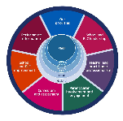  - Improvement in skills and sustained, positive school-leaver destinations for all young people  - Improvement in attainment, particularly in literacy and numeracy.  Stirling Children’s Services Plan  - Improving mental health and emotional wellbeing.  - Tackling child poverty.  - Improving outcomes for children with care experience.  - Improving outcomes for children with disabilities.  - Improving outcomes for children in need of protection.  National Standard for ELC  4.1: The setting uses relevant national self-evaluation frameworks to self-evaluate and systematically identify strengths and areas for improvement  2.2: The setting must have a framework t that is informed by national guidance and supports individual children's development and learning.  5.2: Parents and carers are supported to engage in their child's learning and development.  Articles 3, 5, 6, 12, 18, 23, 24, 28, 29, 31.  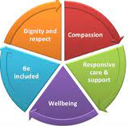  Health & SC Standards: 1.14, 1.15, 1.19, 1.23, 2.15, 2.17.3.5, 3.6, 3.10 | Equity* Respect* Inclusion* Positive relationships* * Diversity* Opportunities* Aspirations*  ACHIEVEMENT: We will raise attainment and achievement for all our children young people by:  - Effectively implementing Stirling ELC numeracy self-evaluation Framework/Strategy (RAINBOW) in all establishments to ensure equity and excellence  - Updating LIFT to become Literacy for Life Self Evaluation Framework/Strategy to intertwine all four literacy skills  - Distributing updated P&L Framework Pathways: Toolkit 2 to offer additional challenge in H&W, Lit and Num progression  - Evaluating impact of digital, STEM & data for improvement  COMMUNITY: We will achieve equity by working in partnership with our children, families and local communities by:  - Redesigning family learning delivery to ensure it is inviting, relevant and accessible to all children and families.  - Building Stirling ELC ‘Pledge to Play’ alongside parents and community partners.  - Working effectively with new Improvement Partnership Quads to validate self-evaluation and QA processes  WELLBEING: We will improve children’s mental and physical health and wellbeing by:  - Making visible Human and Children’s rights to promote: non-discrimination, child at the centre, respect for all and children’s voices  - Targeting poor attendance for Care Experienced children or those at risk from the poverty related equity gap  - Evaluating curriculum and assessment to reflect connectivity of learning  - Working with partners to implement Stirling ELC’ Inclusion starts with I’ framework  - Training programmes to tackle the poverty related equity gap, Mental Wellbeing & Recovery |  | - Improve attainment in literacy and numeracy for children and young people.  - Close the attainment gap between the most and least disadvantaged children and young people for numeracy and literacy.  - Improve the health and wellbeing of children and young people.  - Improve curriculum developments, learning and teaching to support employability skills and sustained positive destinations.  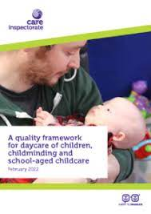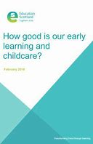  Priority 1:  3.1 Quality Assurance and improvement are led well  1.1,Self-evaluation for self-improvement  Priority 2:  1.1: Nurturing Care and Support  2.4 Personalised support/ 3.1. Ensuring wellbeing, equality and inclusion  Priority 3:  1.4. Family engagement 2.5 Family Learning
Improvement Priority | Outcomes for Learner Statements |  | Impact Measurement
3.1 Quality Assurance and improvement are led well  - A shared vision, values, aims and objectives positively informs practice  - Children and families are meaningfully involved and influence change within the setting  - Quality assurance, including self-evaluation and improvement plans are in place and lead to continuous improvement.  1.1.Self-evaluation for self-improvement  - Collaborative approaches to self-evaluation  - Evidence based improvements  - Ensuring impact of success for children and families | - Children and family aspirations are reflected in the settings vision, values, aims and curriculum rationale.  - Children and family outcomes are improved through effective and collaborative self-evaluation and quality assurance processes.  - Children’s ownership of learning is encouraged and celebrated.  - Children secure progress through high quality interactions, experiences and spaces.  - Children and families Health and Wellbeing benefits from timely interventions, effective partnership working and sustained change.  - Children receive timely early interventions in Lit, Num, and H&W through effective observations, tracking and monitoring and consideration of local and national policy and research.  - Child development is shared between home and setting.  - Children and family learning is innovative and dynamic.  - Children’s progression over time is enhanced through digital literacy, infrastructure and connectivity. |  | - Curriculum and assessment are visibly intertwined, flexible and responsive to meet all children’s individual needs.  - Consultations, decision making processes and democratic voting processes are infused by each child’s voice and rights.  - VSE and setting improvement plans link to NIF priorities and lead to relevant continuous improvement for all.  - A balance of child led, adult led and adult initiated play and learning experiences are planned for and secure progression for all.  - A range and consistency of data show efforts to drive excellence and narrow the poverty related equity gap.
1.1: Nurturing Care and Support  - Children are nurtured and supported throughout their daily experience.  - Children’s individual wellbeing benefits through the use of their personal planning.  3.1. Ensuring wellbeing, equality and inclusion  - Wellbeing  - Fulfilment of statutory duties  - Inclusion and equality  - All children get the support they need to reach their full potential 2.4 Personalised support  - Universal support  - Role of practitioners and leaders  - Identification of learning needs and  targeted support  - Removal of barriers to learning | - Children are safe, secure, nurtured and protected from harm within a fair, safe base.  - Children’s developmental needs are understood and barriers to learning and development are mitigated to secure progress.  - Children’s Play and learning is observed, considered and monitored to ensure progression through appropriate pace, and learning styles.  - Children’s rights are fully embedded in practice and proactively promoted within the wider community.  - Rich observation of children’s engagement during interactions, experiences and spaces, ensure success is planned for, for all.  - Children are proactively supported to explore non-traditional roles in a safe environment without fear of judgement. |  | - All children are encouraged to be independent and lead play and learning, have a voice and are listened to in all matters that affect them.  - H&W and Nurture databases identify and measure the impact of targeted interventions to improve all children’s outcomes.  - Childrens rights/SHANARRI Wellbeing Indicators are explored by all children and understood by most.
1.4. Family engagement  - High-quality engagement facilitates a partnership approach to care, play and learning outcomes  - Staff recognise the importance of engaging families in understanding how to support learning in the child’s home environment  - Well planned early intervention supports and strengthens children’s and families’ overall health, wellbeing, and resilience 2.5 Family Learning  2. 7. Partnerships  - Engagement of parents and carers in the life of the setting  - The promotion of partnerships  - Impact on children and families  - Engaging families in learning  - Intervention and prevention  - Quality of family learning programmes | - Staff recognise the importance of engaging families in understanding how to support learning in the child’s home environment, as a result children secure success through effective partnership working.  - Where needed, well planned early intervention supports and strengthens children’s and families’ overall health, wellbeing, and resilience, ensuring they thrive and flourish.  - Practitioners value and celebrate diversity and actively challenge discrimination.  - Families engage in innovative family learning programmes, particularly in Health and Wellbeing, Literacy and Numeracy.  - Language surrounding PEEP will be softened to ensure engagement from more families. |  | - Through a variety of exciting platforms, all families’ share that they feel loved, cared for and/or respected by the setting.  - All families’ report that they feel valued, and represented within the setting.  - Consultation feedback makes visible the respectful relationships most Care Experienced families have with the setting.  - Children’s attendance has improved through targeted work with some families.

Quality Framework: 3.1 Quality Assurance and improvement are led well HGIOELCC: 1.1.Self-evaluation for self-improvement

National Standard for ELC: 4.1: The setting uses relevant national self-evaluation frameworks to self-evaluate and systematically identify strengths and areas for improvement
National Improvement Framework: Placing the human rights and needs of every child and young person at the centre of education
Stirling children’s Service Plan and RIC: Improving mental health and emotional wellbeing. Tackling child poverty. Improving outcomes for children with care experience. Improving outcomes for children with disabilities. Improving outcomes for children in need of protection.

Outcomes of Learners:
- Children secure progress through a wide range and consistency of data which show efforts to drive excellence and narrow the poverty related equity gap.

Key Actions | Priority Leader | Milestone Dates | Evaluation/Analysis of Progress and impact
- Effective Partnership working with new Improvement Quads will validate self-evaluation and QA processes and strengthen system leadership.  - Updated Lit, Num and H&W Play and Learning Pathways will be shared with practitioners and implemented to enhance early interventions.  - Version 4 of Stirling ELC Mapping Self Evaluation Document will be explored to identify links between National self-evaluation guidance in order to inform improvement.  - Excellence and Equity Leads will work alongside FV RIC to develop innovations to tackle poverty. Partnership with Equity Champions will aim to narrow the poverty related equity gap.  - Targeting of poor attendance for Care Experienced children or those at risk from the poverty related equity gap will be prioritised by Schools, learning and education.  - Children and human rights, The Promise and Pinky Promise are at the heart of all service delivery and are embedded in ethos and culture.  - Data collection is regulation compliant, relevant and robust, tells a story and informs future improvement.  - LIFT will be developed into Literacy for Life Self Evaluation Strategy to ensure targeted literacy interventions.  - RAINBOW will be implemented and intertwined with STEAM to ensure targeted Numeracy interventions and development alongside Science, Technology, Engineering and Art.  - ‘Inclusion starts with I’ Self Evaluation Strategy will be developed alongside ASN and Ed Psy partners to ensure self-evaluation of inclusion for all. | Schools, Learning & Education (SLE) SMT & Champions  SLE/SMT  ALL  SLE/EEL/SMT  SLE/SMT  SLE/SMT  ALL  SLE/Literacy Champions  SLE/Numeracy Champions  SLE/SMT | August 2022  April 2023  August 2022  December 2022  August 2022  May 2022  June 2023  December 2022  June 2023  June 2023

Quality Framework: 1.1: Nurturing Care and Support HGIOELCC: 2.4 Personalised support HGIOELCC: 3.3: Ensuring wellbeing, equality and inclusion

National Standard for ELCC: 2.2: The setting must have a framework t that is informed by national guidance and supports individual children's development and learning.
National Improvement Framework: Improvement in children and young people’s health and wellbeing.
Stirling Childrens Services Improvement Plan and R.I.C: Improve the health and wellbeing of children and young people
.
Outcomes of Learners:
- Children are safe, secure, nurtured and protected from harm within a fair, safe base.
.
Key Actions | Priority Leader | Milestone Dates | Evaluation/Analysis of Progress and impact
- Covid recovery is well paced and includes evaluation of impact of Covid and 1140 on Service delivery.  - Pace of Day Compliance surrounding Child protection, Safeguarding, H&S, Fire procedures, Risk Assessments and Medication will be explored at planned Networks.  - Personal Plans will be further developed to streamline and to include children’s voice.  - Effective partnership working with ASN and Ed Psy ensure Restorative Approaches and Neuro- sequential Model in Education (NME) training is available to settings who are nurture ready.  - Impact meetings and the Play & Learning Tracking & Monitoring database 3 x yearly, identify gaps in communication, early language, mathematics and H&W to inform targeted interventions.  - All settings will make visible Human and Children’s rights to promote a ‘needs led’ and ‘rights based’ curriculum that is flexible and responsive to local need and national guidance.  - Play Champions will continue to develop Stirling’s Pledge to Play, and children’s right to play within settings and communities.  - Setting the Table short life working group will be established to inform settings practice and policy surrounding healthy eating in Stirling ELC.  - Data stories show the impact of universal, targeted and enhanced interventions on outcomes for children; particularly those at risk of the poverty related equity gap and Care Experienced.  - Curriculum and assessment will be evaluated together within settings to reflect connectivity, relevance and ensure a curriculum for a rapidly changing world.  - Short Life working group will be established with Ed Psy and ASN to ensure Stirling ASN Offer and ELC’ Inclusion starts with I’ framework enhances each settings inclusive practice.  - Training programmes to tackle the poverty related equity gap, Mental Wellbeing & Recovery will be explored through learning communities and Improvement Partnerships. | SMT  SMT  Short Life Working Group  SMT  SMT  SMT/ Nurture Champions  Play Champions  Short Life working group  SMT/ Practitioners  SMT/ Practitioners  SLE/SMT  SMT | September 2022  June 2023  December 2022  June 2023  June 2023  January 2023  May 2023  January 2023  November 2022  June 2023  June 2023  June 2023
Quality Framework: 1.4 Family engagement HGIOELCC: 2.5 Family Learning HGIOELCC: 3.3: Ensuring wellbeing, equality and inclusion

National Improvement Framework: Improvement in attainment, particularly in literacy and numeracy.
National Standard for ELCC: 5.2: Parents and carers are supported to engage in their child's learning and development. Improvement in children and young people’s health and wellbeing
Stirling Childrens Services Improvement Plan and R.I.C: Improve attainment in literacy and numeracy for children and young people. Close the attainment gap between the most and least disadvantaged children and young people for numeracy and literacy. Improve the health and wellbeing of children and young people.
Outcomes of Learners:
- High-quality engagement facilitates a partnership approach to care, play and securing positive outcomes

Key Actions | Priority Leader | Milestone Dates | Evaluation/Analysis of Progress and impact
- Regular consultations are held with families to ensure Covid Recovery is well paced and meets the needs of children, families and of the setting.  - Redesign family learning delivery and ensure PEEP is inviting, relevant and accessible to all children and families.  - Education Scotland Engaging parents and families: A toolkit for Practitioners is explored alongside Family Learning Framework to ensure families have ample opportunity to engage, become involved, contribute to children’s learning, and participate in family learning.  - Nurturing conversations based on respectful reciprocal relationships with families and knowledge of individual circumstances will signpost them to FME, Family Nursing Partnerships, Thrive to Maximise and other support services, if relevant.  - Building Stirling ELC ‘Pledge to Play’ alongside parents and community partners to ensure our communities embrace and respect play and understand the benefits of outdoor play.  - Creative approaches are used to engage families to be fully involved across all aspects of their children’s play and learning.  - Evaluating impact of digital, STEM & data for improvement to ensure families are connected. | SMT/SLE  SMT/SLE  SMT/Practitioners  SMT  SMT/Practitioners as agreed  SMT/Play Champions  SMT/Practitioners  SMT/Practitioners | August 2022  June 2023  May 2023  May 2023  May 2023  June 2023  September 2022  June 2023

